Docker Task- 03
Task 1: Create an image from a running container
Step 1: Check Docker
docker --version
sudo systemctl status docker
If Docker is active, continue.
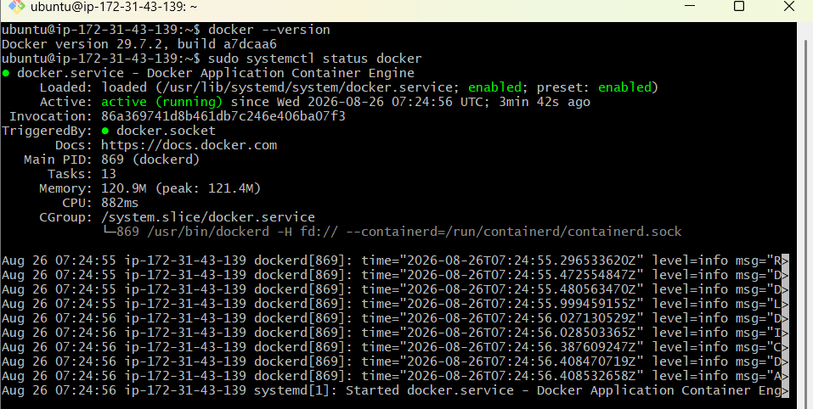
Step 2: Create an Nginx container
docker run -d \
--name task1-nginx \
-p 8083:80 \
nginx:alpine
Verify:
docker ps
curl http://localhost:8083
You should see the default Nginx page.

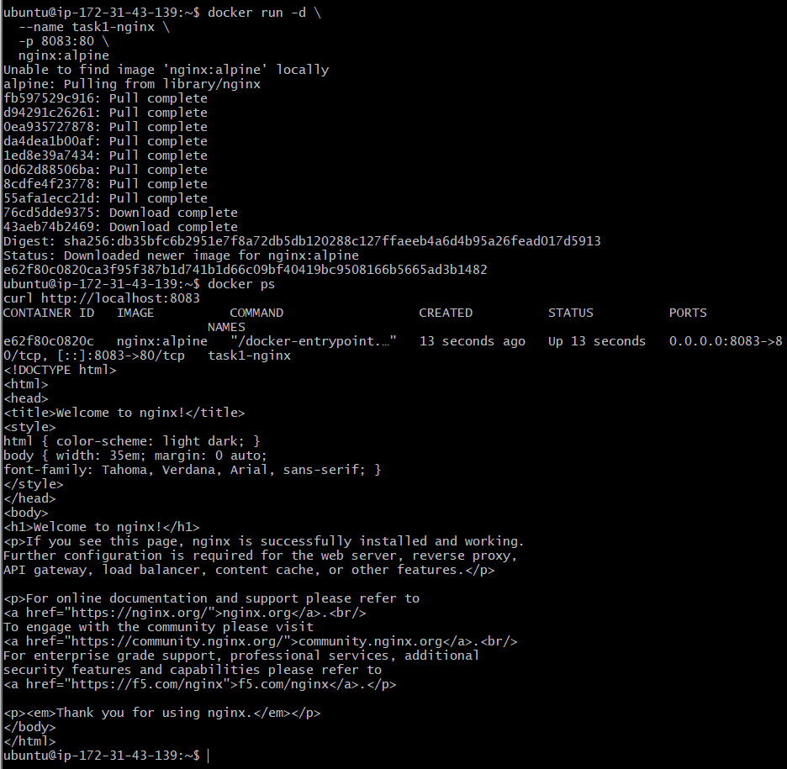
Step 3: Customize the running container
docker exec task1-nginx sh -c \
'echo "<h1>Custom Docker Image Created by Venu</h1>" > /usr/share/nginx/html/index.html'
Test it:
curl http://localhost:8083
Expected:
<h1>Custom Docker Image Created by Venu</h1>
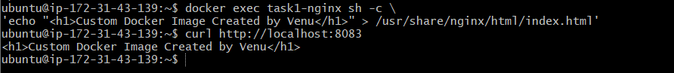
Step 4: Create an image from the container
docker commit \
task1-nginx \
venu-nginx-custom:v1
Verify the image:
docker images venu-nginx-custom
Expected format:
REPOSITORY TAG IMAGE ID CREATED
venu-nginx-custom v1 xxxxxxxxxxxx few seconds ago
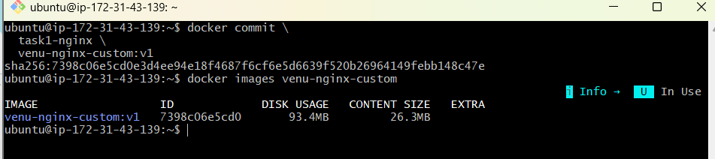
Step 5: Create another container from the new image
docker run -d \
--name task1-custom-nginx \
-p 8084:80 \
venu-nginx-custom:v1
Verify:
docker ps
curl http://localhost:8084
Expected:
<h1>Custom Docker Image Created by Venu</h1>
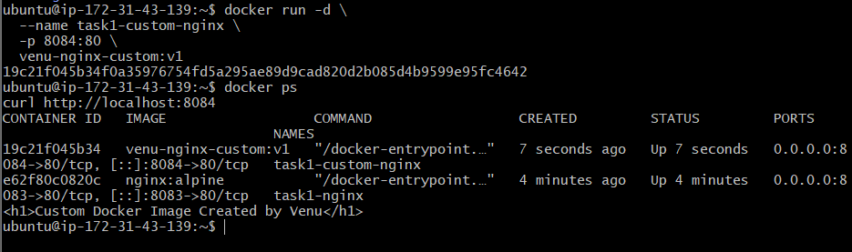
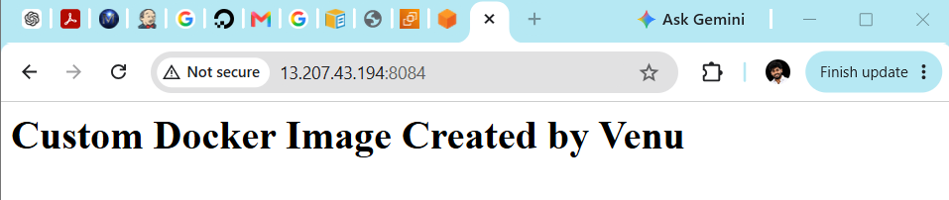

Task 2: Copy Docker image from local machine to Docker server
We will use this flow:
Local Docker image → docker save → TAR file → SCP → EC2 → docker load
Step 1: Check Docker on your Windows local machine
Open Git Bash and run:
docker --version
docker info
Docker Desktop must be running.
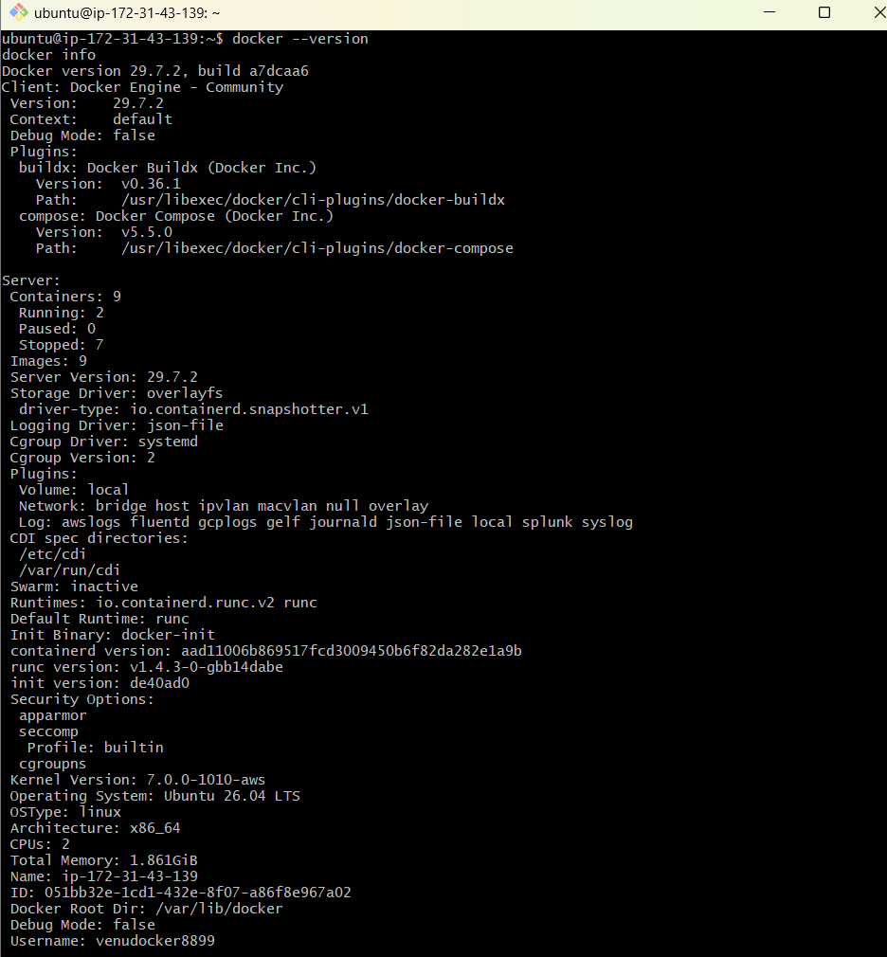

Step 2: Pull an image locally
docker pull nginx:alpine
Verify:
docker images nginx
Step 3: Save the image as a TAR file
docker save -o nginx-alpine.tar nginx:alpine
Verify the file:
ls -lh nginx-alpine.tar
Important:
- docker save converts a Docker image into a transferable archive.
- Use .tar, not .zip.
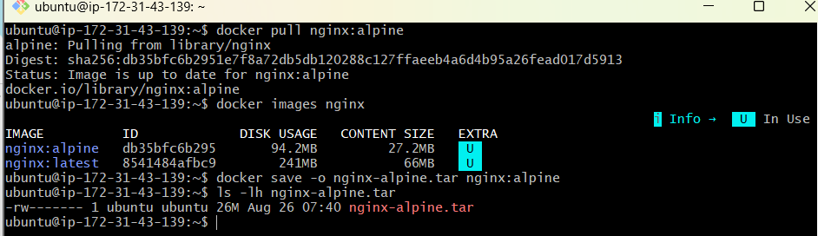
Step 4: Find your EC2 key
If your key is in the Windows Downloads folder:
find /c/Users -name "docker-practice-key.pem" 2>/dev/null
Example result:
/c/Users/kunch/Downloads/docker-practice-key.pem
Set key permission:
chmod 400 /c/Users/kunch/Downloads/docker-practice-key.pem
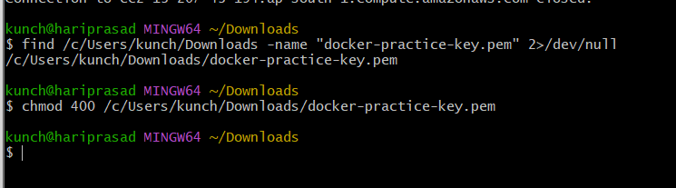
Replace the path if your result is different.
Step 5: Copy the TAR file to EC2
Replace EC2_PUBLIC_IP with your Docker server’s public IP:
scp -i /c/Users/kunch/Downloads/docker-practice-key.pem \
nginx-alpine.tar \
ubuntu@EC2_PUBLIC_IP:/home/ubuntu/
Example:
scp -i /c/Users/kunch/Downloads/docker-practice-key.pem \
nginx-alpine.tar \
ubuntu@13.203.10.20:/home/ubuntu/
Expected output:
nginx-alpine.tar 100%
Only SSH port 22 needs to be allowed from your IP in the EC2 security group.
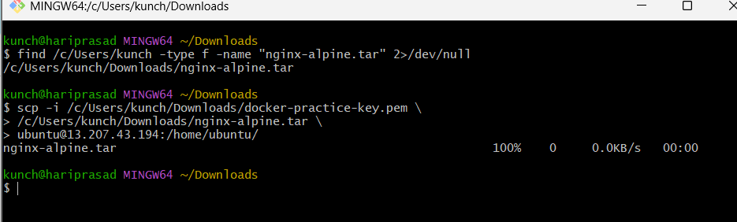
Step 6: Connect to the Docker server
ssh -i /c/Users/kunch/Downloads/docker-practice-key.pem \
ubuntu@EC2_PUBLIC_IP
Step 7: Verify the copied file
On the EC2 server:
ls -lh /home/ubuntu/nginx-alpine.tar
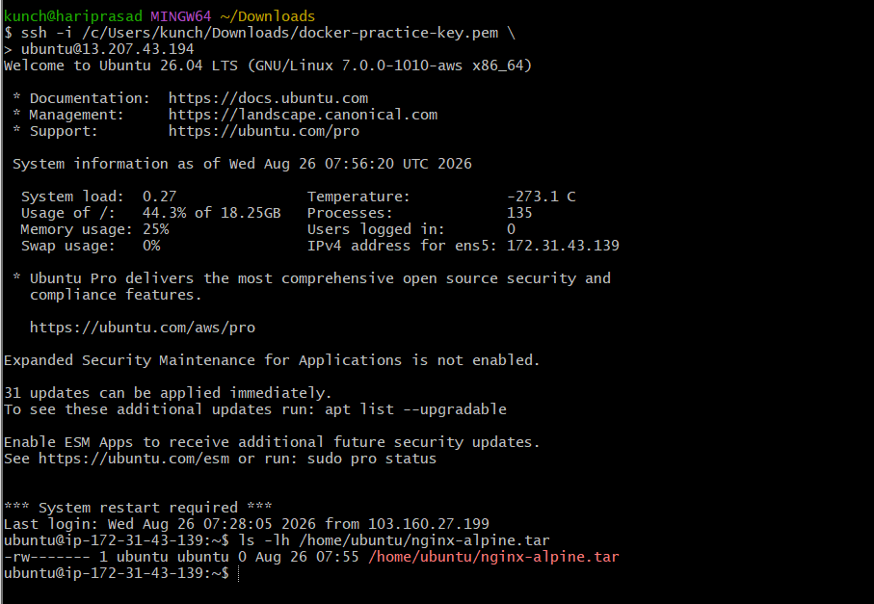
Step 8: Load the image
docker load -i nginx-alpine.tar
Expected:
Loaded image: nginx:alpine
Verify:
docker images nginx
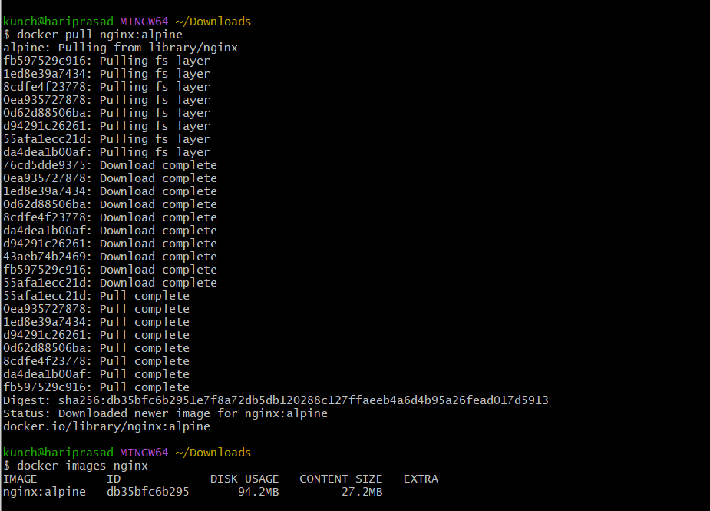
Step 9: Run a container using the loaded image
docker run -d \
--name task2-nginx \
-p 8085:80 \
nginx:alpine
Test:
docker ps
curl http://localhost:8085
You should receive the Nginx welcome page.
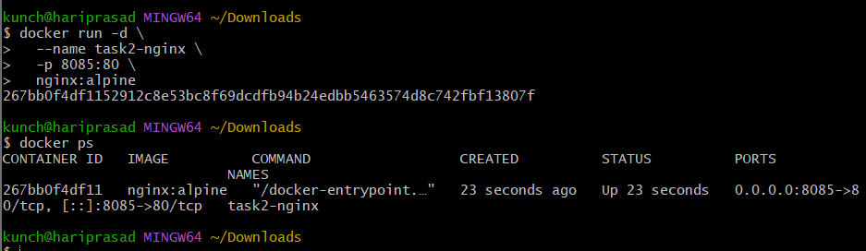
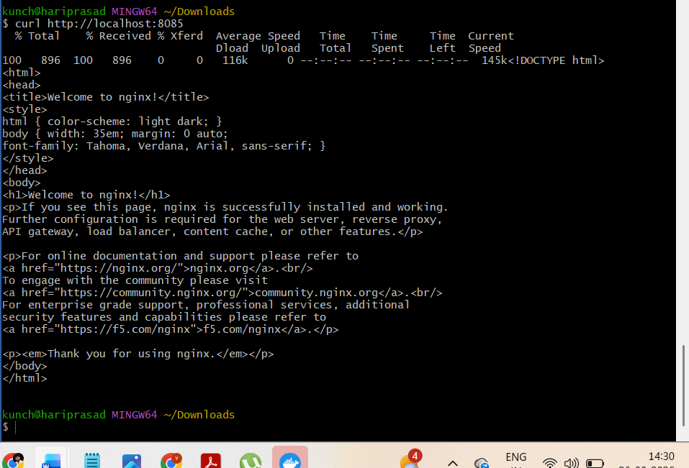

Now transfer the image to EC2
1. Save the local image
Run in Windows Git Bash:
docker save \
-o /c/Users/kunch/Downloads/nginx-alpine.tar \
nginx:alpine
Confirm that it is not empty:
ls -lh /c/Users/kunch/Downloads/nginx-alpine.tar
The size must be greater than 0.
2. Copy the image to EC2
scp -i /c/Users/kunch/Downloads/docker-practice-key.pem \
/c/Users/kunch/Downloads/nginx-alpine.tar \
ubuntu@13.207.43.194:/home/ubuntu/nginx-alpine.tar
Wait for:
100%
This will overwrite the existing empty TAR file on EC2.
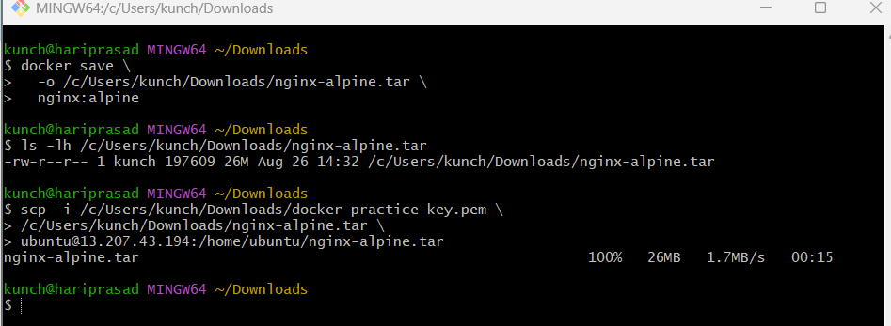
3. Connect to EC2
ssh -i /c/Users/kunch/Downloads/docker-practice-key.pem \
ubuntu@13.207.43.194
Your prompt must change to:
ubuntu@ip-172-31-43-139:~$
4. Verify and load the image on EC2
ls -lh nginx-alpine.tar
Make sure it is not 0 bytes. Then:
docker load -i nginx-alpine.tar
Expected:
Loaded image: nginx:alpine
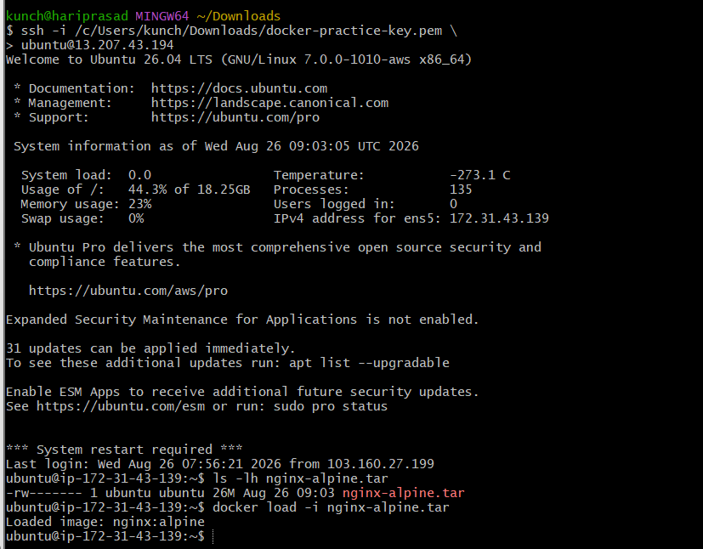
5. Run it on the EC2 server
Because task2-nginx exists only locally, this should work on EC2:
docker run -d \
--name task2-nginx \
-p 8085:80 \
nginx:alpine
Verify from EC2:
docker ps
curl http://localhost:8085
To access it from Windows using the public IP, add this EC2 security-group inbound rule:
Type: Custom TCP
Port: 8085
Source: My IP
Then test from Windows:
curl http://13.207.43.194:8085
The key point is to watch the prompt:
- kunch@hariprasad = local Windows machine
- ubuntu@ip-172-31-43-139 = EC2 Docker server
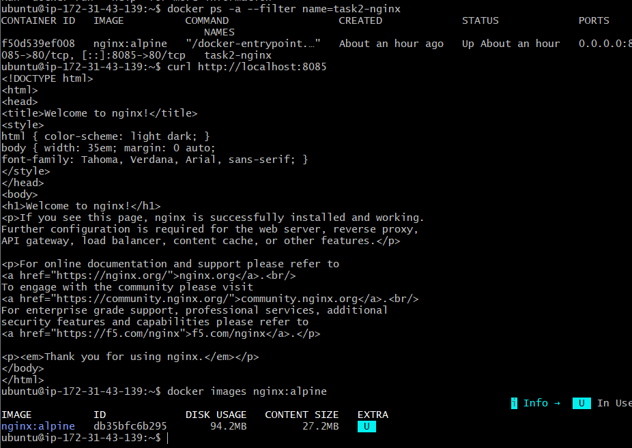

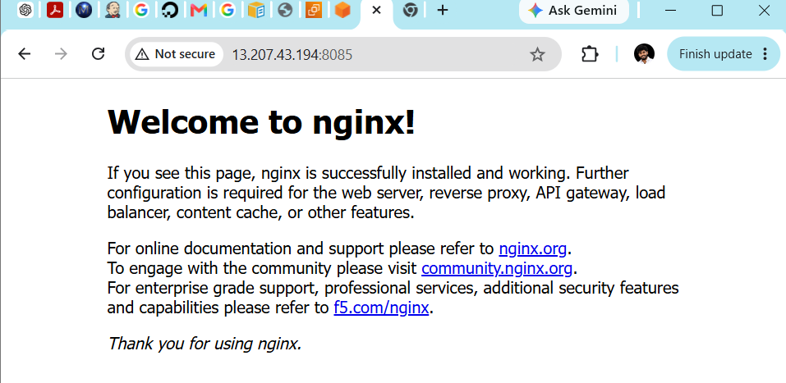

Task 3: Create an Alpine-based image customized with Tomcat
We will create:
Alpine Linux → Java 21 → Tomcat 10 → Custom webpage
Run these commands on the EC2 Docker server:
ubuntu@ip-172-31-43-139
Step 1: Create the project directory
mkdir -p ~/alpine-tomcat
cd ~/alpine-tomcat
Step 2: Create the custom webpage
nano index.html
Paste:
<!DOCTYPE html>
<html>
<head>
<title>Alpine Tomcat</title>
</head>
<body>
<h1>Welcome to Venu's Alpine Tomcat Image</h1>
<p>Alpine Linux + Java 21 + Apache Tomcat 10</p>
</body>
</html>
Save using:
Ctrl+O → Enter → Ctrl+X
Step 3: Create the Dockerfile
nano Dockerfile
Paste:
FROM alpine:3.23

LABEL maintainer="Venu Gopal"

ENV JAVA_HOME=/usr/lib/jvm/java-21-openjdk
ENV CATALINA_HOME=/opt/tomcat
ENV PATH="${CATALINA_HOME}/bin:${JAVA_HOME}/bin:${PATH}"
ENV TOMCAT_VERSION=10.1.57

RUN apk add --no-cache openjdk21-jre curl tar \
&& mkdir -p ${CATALINA_HOME} \
&& curl -fsSL \
"https://dlcdn.apache.org/tomcat/tomcat-10/v${TOMCAT_VERSION}/bin/apache-tomcat-${TOMCAT_VERSION}.tar.gz" \
-o /tmp/tomcat.tar.gz \
&& tar -xzf /tmp/tomcat.tar.gz \
--strip-components=1 \
-C ${CATALINA_HOME} \
&& rm -f /tmp/tomcat.tar.gz \
&& rm -rf ${CATALINA_HOME}/webapps/ROOT \
&& mkdir -p ${CATALINA_HOME}/webapps/ROOT

COPY index.html ${CATALINA_HOME}/webapps/ROOT/index.html

EXPOSE 8080

CMD ["catalina.sh", "run"]
Save:
Ctrl+O → Enter → Ctrl+X
Apache lists Tomcat 10.1.57 as a Tomcat 10 release. Apache Tomcat documentation
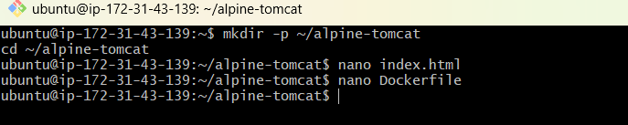
Step 4: Verify the files
ls -l
Expected:
Dockerfile
index.html
Display the Dockerfile:
cat Dockerfile
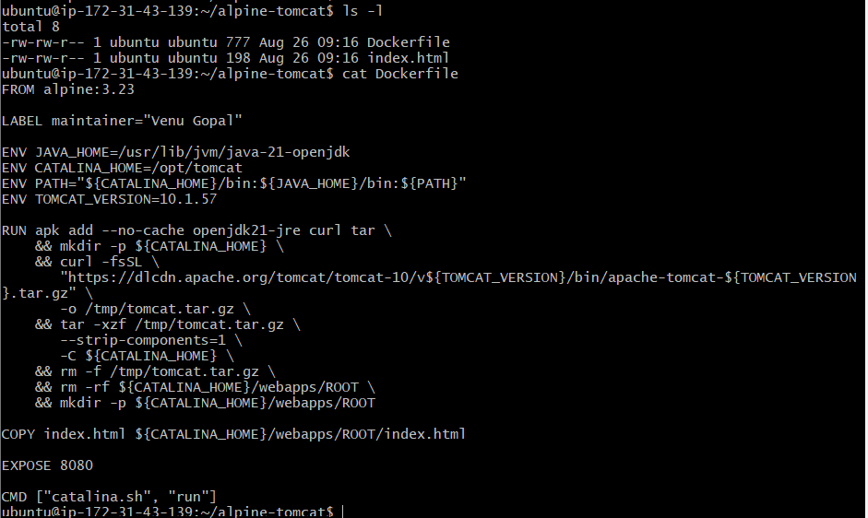
Step 5: Build the updated Alpine-Tomcat image
Confirm your current directory:
pwd
Expected:
/home/ubuntu/alpine-tomcat
Confirm the required files:
ls -l
You should see:
Dockerfile
index.html
Build the image without using the failed build cache:
docker build --no-cache \
-t venu-alpine-tomcat:v1 .
Wait until you see something similar to:
Successfully tagged venu-alpine-tomcat:v1
Verify the image:
docker images venu-alpine-tomcat
Expected format:
REPOSITORY TAG IMAGE ID CREATED
venu-alpine-tomcat v1 xxxxxxxxxxxx seconds ago
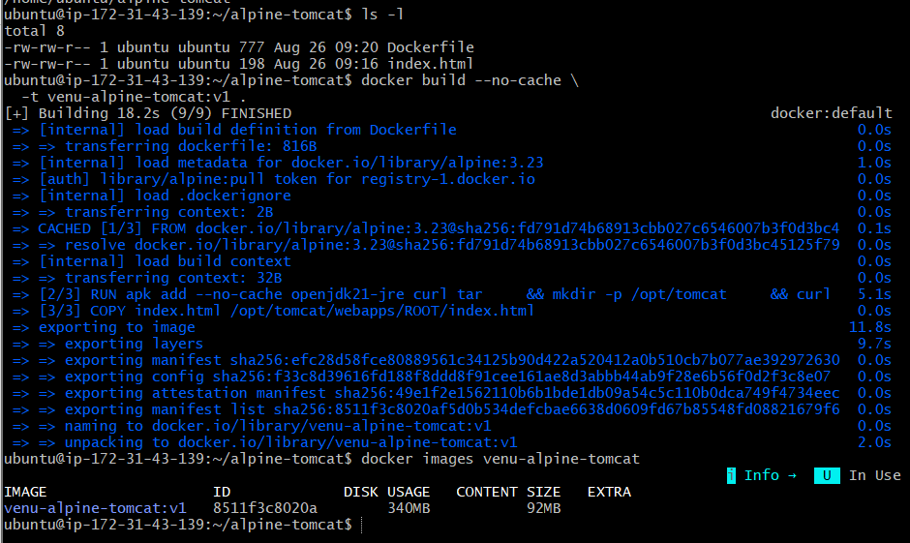
Step 6: Run the container
First check whether a container with the same name already exists:
docker ps -a --filter name=alpine-tomcat
If no container is displayed
Run:
docker run -d \
--name alpine-tomcat \
-p 8086:8080 \
venu-alpine-tomcat:v1

Check the container:
docker ps --filter name=alpine-tomcat
Expected:
STATUS PORTS
Up ... 0.0.0.0:8086->8080/tcp
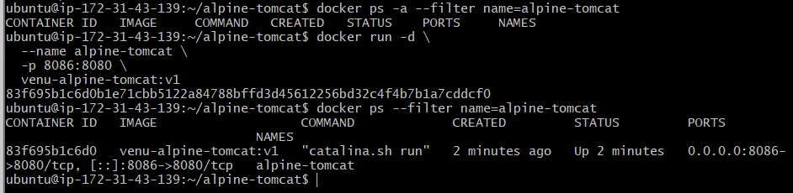
Step 7: Check the Tomcat logs
docker logs alpine-tomcat
Near the bottom, look for:
Server startup in [...] milliseconds
You can also show only the last 30 lines:
docker logs --tail 30 alpine-tomcat
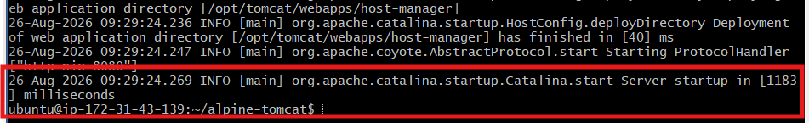

Step 8: Test the customized Tomcat application
Test from the EC2 server:
curl http://localhost:8086
Expected output:
<!DOCTYPE html>
<html>
<head>
<title>Alpine Tomcat</title>
</head>
<body>
<h1>Welcome to Venu's Alpine Tomcat Image</h1>
<p>Alpine Linux + Java 21 + Apache Tomcat 10</p>
</body>
</html>
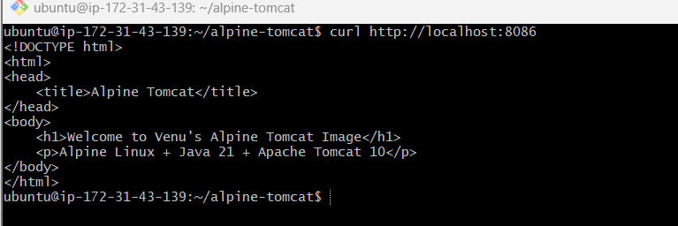
Step 9: Access it from Windows
In the EC2 security group, add:
Type: Custom TCP
Port range: 8086
Source: My IP
Description: Alpine Tomcat
Then open:
http://13.207.43.194:8086
Run this now:
docker build --no-cache \
-t venu-alpine-tomcat:v1 .
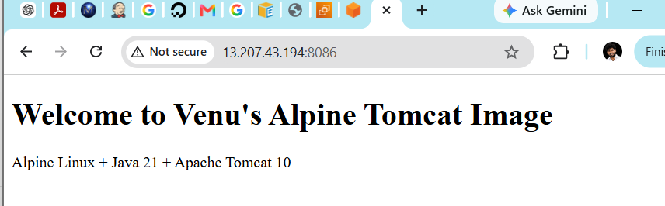

Task 4: Single-stage and multi-stage Dockerfiles
Source repository: betawins/multi-stage-example
This is a Java Spring Boot Maven application. We will create two separate Dockerfiles without changing the repository’s existing Dockerfile.
Step 1: Clone the source code
Run on your EC2 Docker server:
cd ~
git clone https://github.com/betawins/multi-stage-example.git
Enter the repository:
cd ~/multi-stage-example
Check the branch and files:
git branch --show-current
ls -la
You should see:
pom.xml
mvnw
src
Dockerfile
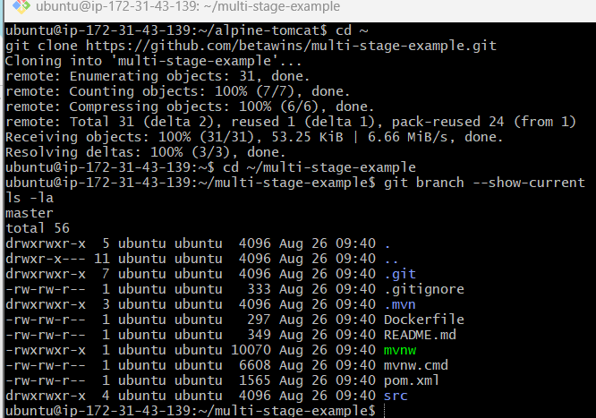
Part A: Single-stage Dockerfile
In a single-stage build, Maven, source code and the final JAR remain inside the same image.
Step 2: Create Dockerfile.single
nano Dockerfile.single
Paste:
FROM maven:3.8.8-eclipse-temurin-8

LABEL maintainer="Venu Gopal"

WORKDIR /app

COPY pom.xml .
COPY src ./src

RUN mvn clean package -DskipTests

EXPOSE 8080

CMD ["java", "-jar", "target/multi-stage-example-0.0.1-SNAPSHOT.jar"]
Save:
Ctrl+O → Enter → Ctrl+X
Verify:
cat Dockerfile.single
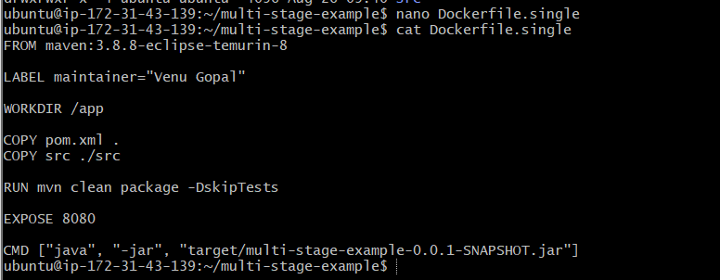
Step 3: Build the single-stage image
docker build \
-f Dockerfile.single \
-t venu-multistage-app:single .
Verify:
docker images venu-multistage-app
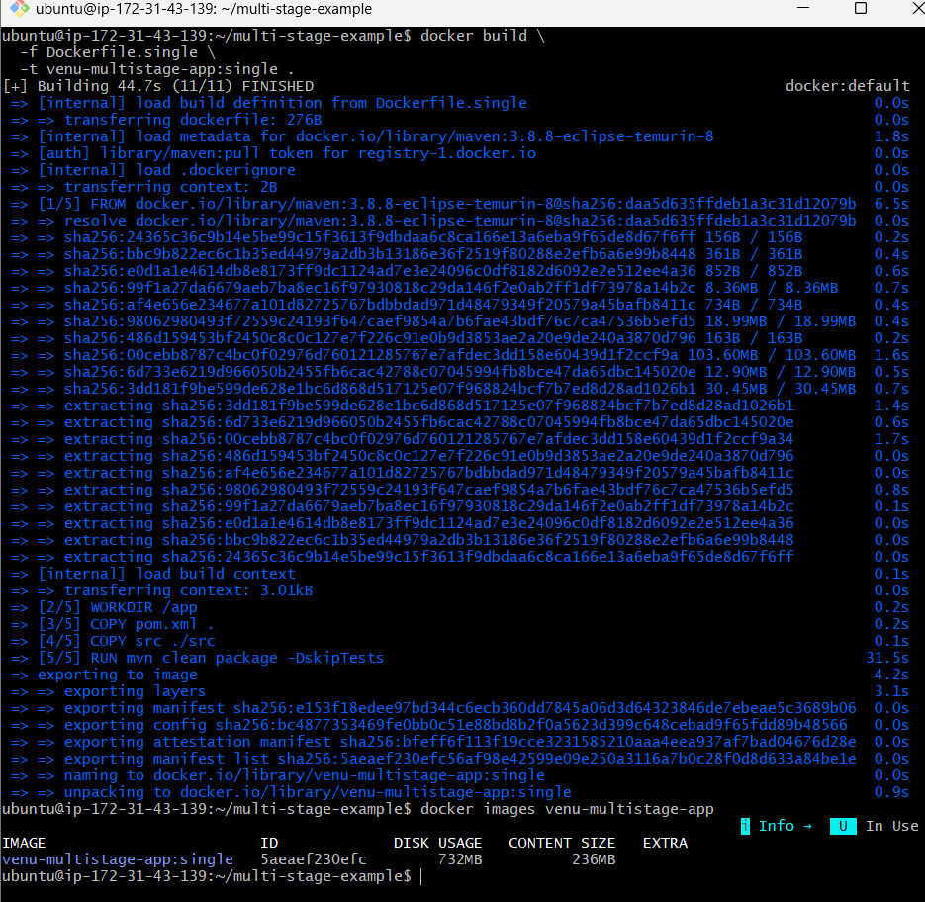
Step 4: Run the single-stage container
docker run -d \
--name single-stage-app \
-p 8087:8080 \
venu-multistage-app:single
Check status:
docker ps --filter name=single-stage-app
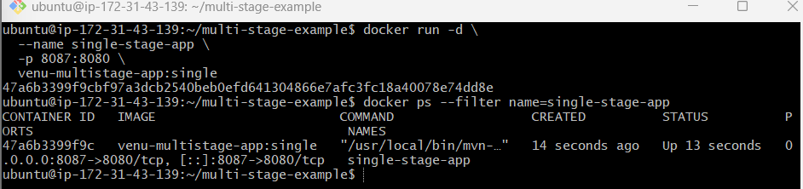
Check logs:
docker logs --tail 30 single-stage-app
Look for:
Started MultiStageExampleApplication
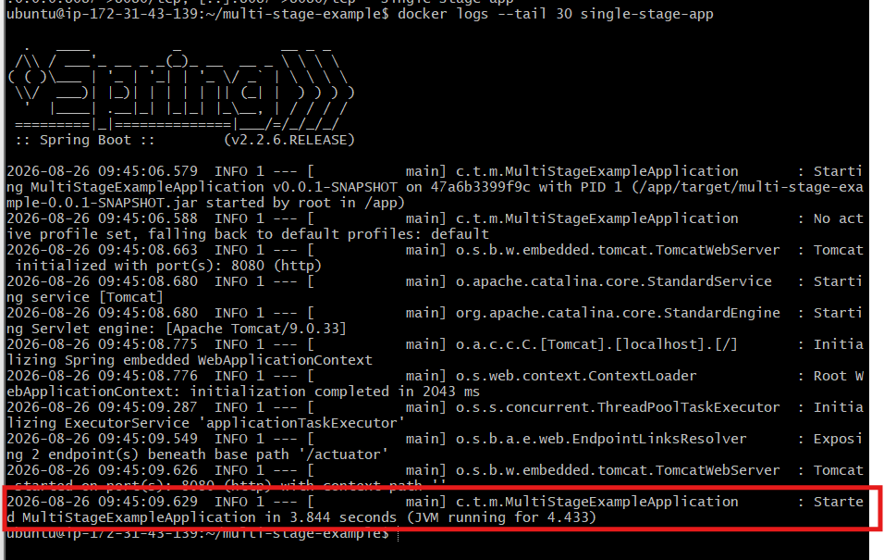
Step 5: Test the application
curl http://localhost:8087/actuator/health
Expected:
{"status":"UP"}
If the application defines a root endpoint, you can also test:
curl http://localhost:8087/
Complete the single-stage build first. After it succeeds, we’ll create Dockerfile.multi, build the smaller runtime image, and compare both image sizes.
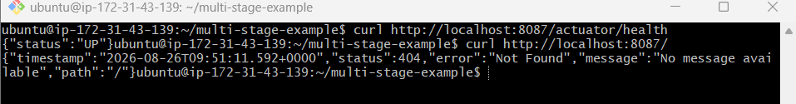
The single-stage application is working correctly:
{"status":"UP"}
The / endpoint returns 404 because this application does not define a root controller. It is not a Docker problem. The correct health endpoint is:
/actuator/health
Part B: Multi-stage Dockerfile
The multi-stage build uses:
Stage 1: Maven + source code → Build JAR
Stage 2: Java runtime only → Run JAR
Step 6: Create Dockerfile.multi
You are already inside:
~/multi-stage-example
Create the file:
nano Dockerfile.multi
Paste:
# Stage 1: Build the application
FROM maven:3.8.8-eclipse-temurin-8 AS builder

WORKDIR /app

COPY pom.xml .
COPY src ./src

RUN mvn clean package -DskipTests

# Stage 2: Run the application
FROM eclipse-temurin:8-jre-alpine

LABEL maintainer="Venu Gopal"

WORKDIR /app

COPY --from=builder \
/app/target/multi-stage-example-0.0.1-SNAPSHOT.jar \
app.jar

EXPOSE 8080

ENTRYPOINT ["java", "-jar", "app.jar"]
Save:
Ctrl+O → Enter → Ctrl+X
Verify:
cat Dockerfile.multi
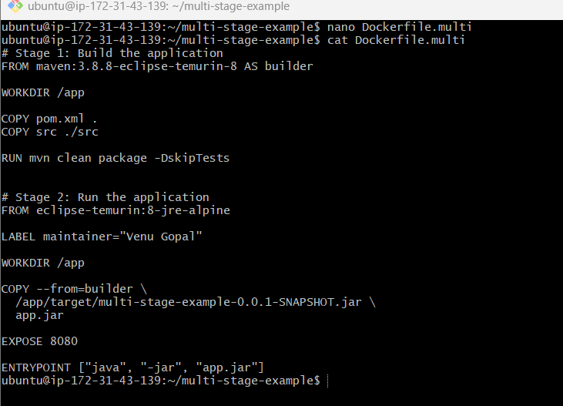
Step 7: Build the multi-stage image
docker build \
-f Dockerfile.multi \
-t venu-multistage-app:multi .
Verify:
docker images venu-multistage-app
You should now see both tags:
venu-multistage-app single
venu-multistage-app multi
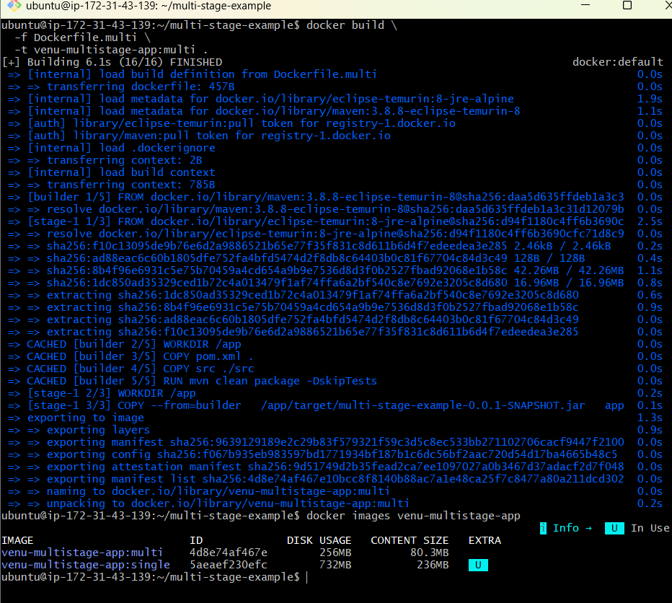
Step 8: Run the multi-stage container
docker run -d \
--name multi-stage-app \
-p 8088:8080 \
venu-multistage-app:multi
Check status:
docker ps --filter name=multi-stage-app
Check logs:
docker logs --tail 30 multi-stage-app
Look for:
Started MultiStageExampleApplication
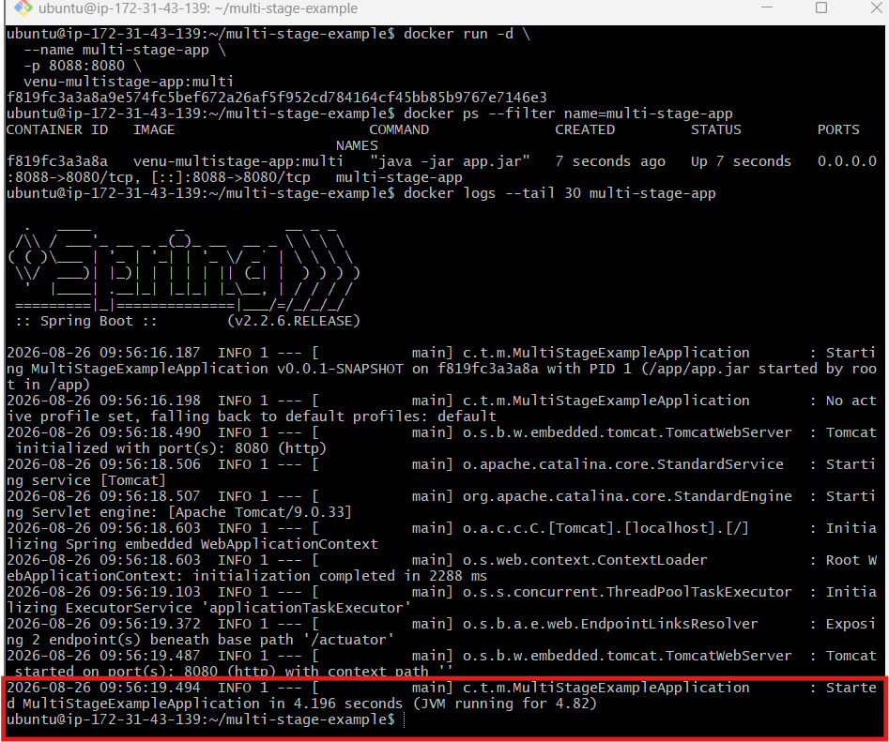
Step 9: Test the multi-stage application
curl http://localhost:8088/actuator/health
Expected:
{"status":"UP"}
Step 10: Compare image sizes
docker images venu-multistage-app \
--format "table {{.Repository}}\t{{.Tag}}\t{{.Size}}"
Expected concept:
Image | Contents | Size
single | Maven, JDK, source and JAR | Larger
multi | Java runtime and JAR | Smaller

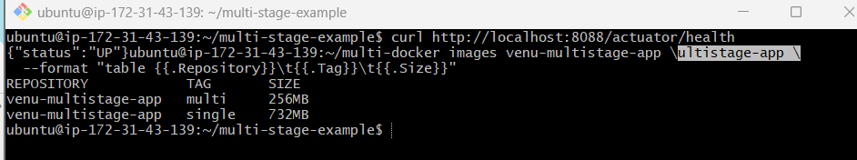

Testing inside EC2 with:
curl http://localhost:8088/actuator/health
Add an inbound rule for 8088 only if you want to access the application from your Windows browser or another external machine.
Use:
Type: Custom TCP
Port range: 8088
Source: My IP
Description: Multi-stage Docker app
Then test from Windows:
http://13.207.43.194:8088/actuator/health
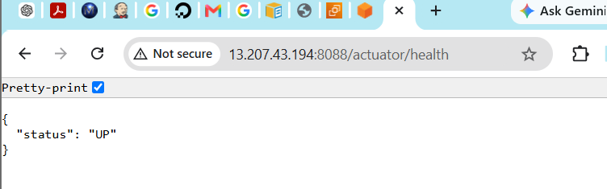

Task 5: Install Docker Compose and run a sample application
We will run a two-container application:
Python Flask web app → Redis database
Docker Compose will create and manage both containers.
Step 1: Check Docker Compose
Run on the EC2 Docker server:
docker compose version
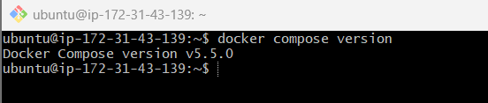
If it displays a version, Compose is already installed. Skip to Step 2.
If it says Compose is unavailable:
sudo apt update
sudo apt install -y docker-compose-plugin
Verify:
docker compose version
Use the modern command:
docker compose
The older docker-compose command is considered legacy.
Step 2: Create the sample project
cd ~
mkdir -p compose-sample
cd compose-sample
Create app.py
nano app.py
Paste:
from flask import Flask
import redis

app = Flask(__name__)

database = redis.Redis(
host="redis",
port=6379,
decode_responses=True
)

@app.route("/")
def home():
visits = database.incr("visits")

return f"""
<h1>Docker Compose Application</h1>
<h2>Created by Venu</h2>
<p>This page has been visited {visits} times.</p>
"""

if __name__ == "__main__":
app.run(host="0.0.0.0", port=5000)
Save:
Ctrl+O → Enter → Ctrl+X
Step 3: Create requirements.txt
nano requirements.txt
Paste:
Flask>=3,<4
redis>=5,<7
Save:
Ctrl+O → Enter → Ctrl+X
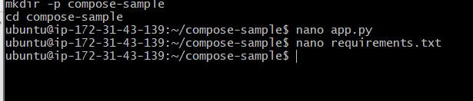
Step 4: Create the application Dockerfile
nano Dockerfile
Paste:
FROM python:3.12-alpine

WORKDIR /app

COPY requirements.txt .

RUN pip install --no-cache-dir -r requirements.txt

COPY app.py .

EXPOSE 5000

CMD ["python", "app.py"]
Save the file.
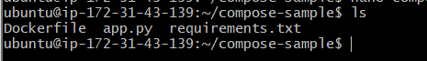
Step 5: Create compose.yaml
nano compose.yaml
Paste:
services:
redis:
image: redis:7-alpine
container_name: compose-redis
restart: unless-stopped
healthcheck:
test: ["CMD", "redis-cli", "ping"]
interval: 5s
timeout: 3s
retries: 5

web:
build: .
container_name: compose-web
restart: unless-stopped
ports:
- "8089:5000"
depends_on:
redis:
condition: service_healthy
Save the file.
Notice that the application connects to Redis using:
host="redis"
redis is the Compose service name. Docker Compose provides automatic DNS resolution between services.
Step 6: Verify all files
ls -l
Expected:
Dockerfile
app.py
compose.yaml
requirements.txt
Validate the Compose file:
docker compose config
If there are no errors, continue.
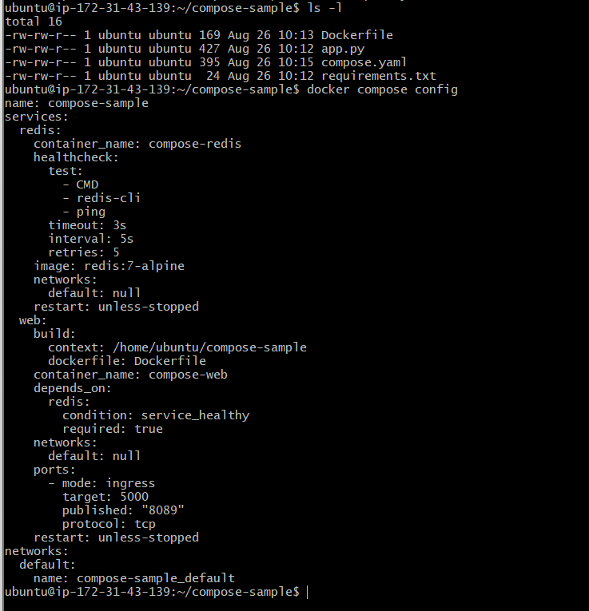
Step 7: Build and start the application
docker compose up -d --build
Check both containers:
docker compose ps
Expected:
compose-redis Up (healthy)
compose-web Up

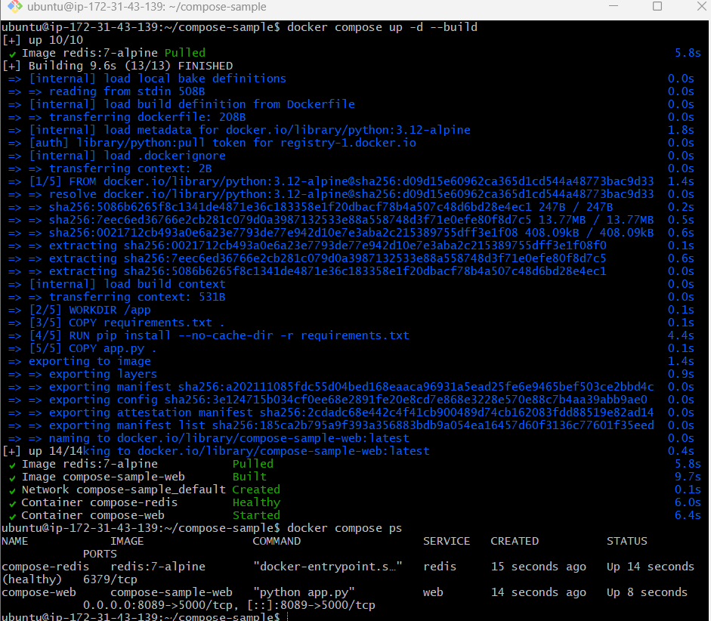
Step 8: Check logs
docker compose logs
Or check only the web application:
docker compose logs web
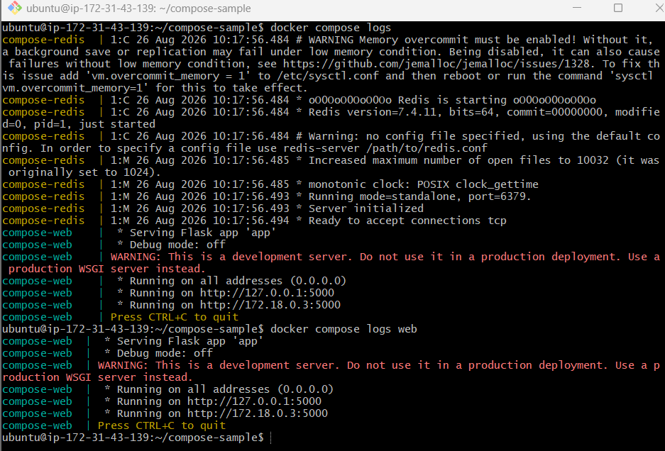
Step 9: Test the application
curl http://localhost:8089
Expected:
<h1>Docker Compose Application</h1>
<h2>Created by Venu</h2>
<p>This page has been visited 1 times.</p>
Run it again:
curl http://localhost:8089
The counter should increase:
This page has been visited 2 times.
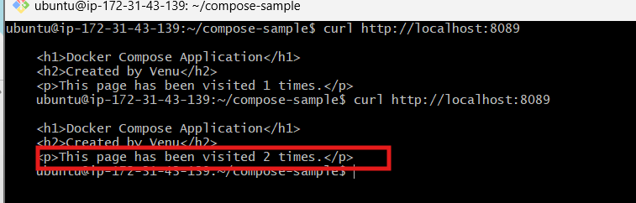
Step 10: Useful Compose commands
docker compose ps
docker compose logs
docker compose stop
docker compose start
docker compose restart
docker compose down
Do not run docker compose down until we finish verification.
You only need security-group port 8089 if you want to open the application from Windows:
Type: Custom TCP
Port: 8089
Source: My IP
Then open:
http://13.207.43.194:8089
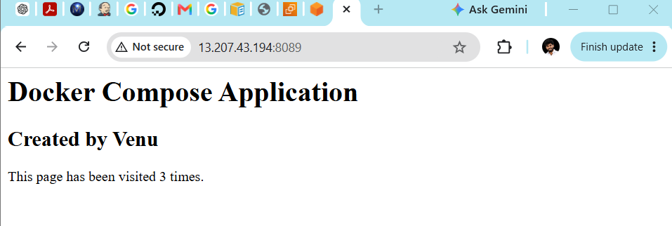

Task 6: Scan images pushed to Docker Hub
We will use:
Docker image → Docker Hub push → Trivy registry scan → Pass/Fail
We’ll use your Docker Hub username:
venudocker8899
Step 1: Install Trivy on the EC2 Docker server
Check whether it is already installed:
trivy --version
If it says command not found, install it:
sudo apt-get update
sudo apt-get install -y wget gnupg
Add the Trivy signing key:
wget -qO - \
https://aquasecurity.github.io/trivy-repo/deb/public.key \
| gpg --dearmor \
| sudo tee /usr/share/keyrings/trivy.gpg > /dev/null
Add the Trivy repository:
echo "deb [signed-by=/usr/share/keyrings/trivy.gpg] https://aquasecurity.github.io/trivy-repo/deb generic main" \
| sudo tee /etc/apt/sources.list.d/trivy.list
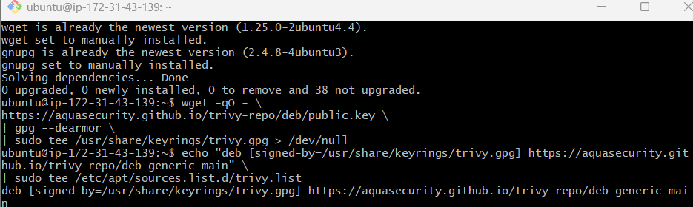
Install Trivy:
sudo apt-get update
sudo apt-get install -y trivy
Verify:
trivy --version
These are the official Ubuntu installation steps from Trivy documentation.
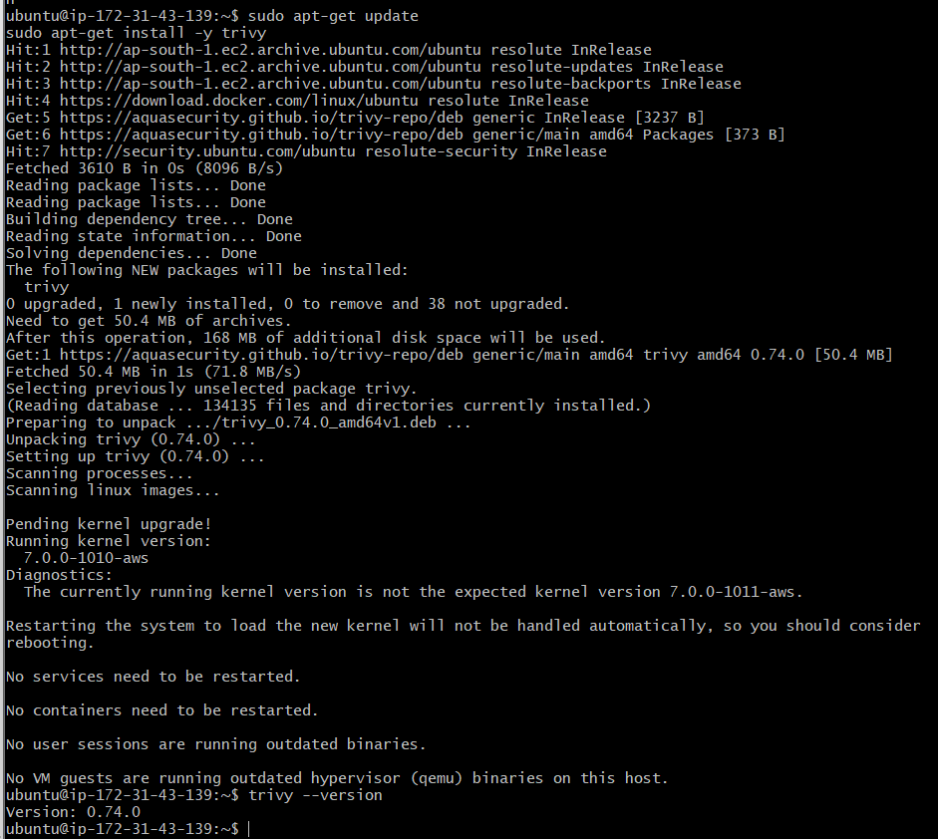
Step 2: Create a Docker Hub repository
In Docker Hub, create a new public repository:
Repository name: docker-security-demo
Visibility: Public
The complete repository will be:
venudocker8899/docker-security-demo
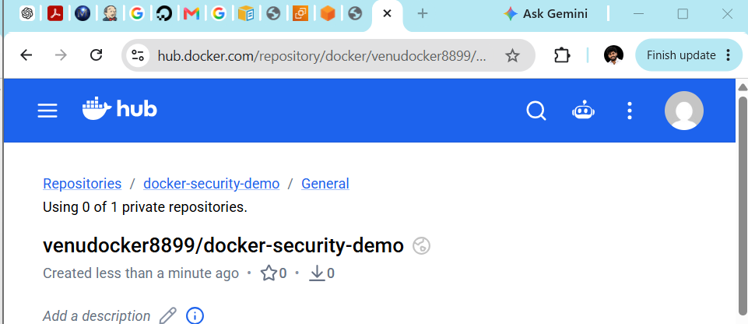
Step 3: Tag the Alpine-Tomcat image
Check that your Task 3 image exists:
docker images venu-alpine-tomcat
Tag it:
docker tag \
venu-alpine-tomcat:v1 \
venudocker8899/docker-security-demo:v1
Verify:
docker images venudocker8899/docker-security-demo
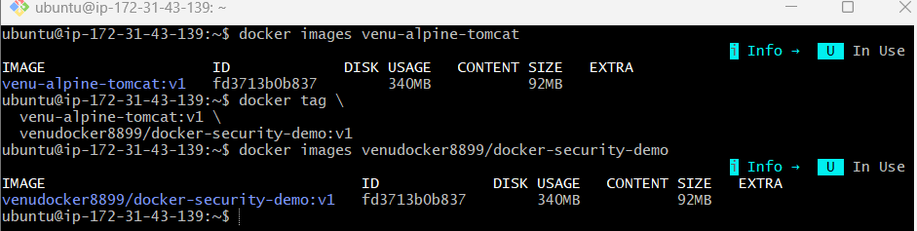
Because /tmp has insufficient quota for the Java database, we will use:
- /home/ubuntu/trivy-tmp for temporary files
- OS vulnerability scanning
- Docker Hub remote registry scanning
Step 4: Scan the local image before pushing
Create the Trivy temporary directory:
mkdir -p /home/ubuntu/trivy-tmp
Scan the local image:
TMPDIR=/home/ubuntu/trivy-tmp \
trivy image \
--scanners vuln \
--pkg-types os \
venudocker8899/docker-security-demo:v1
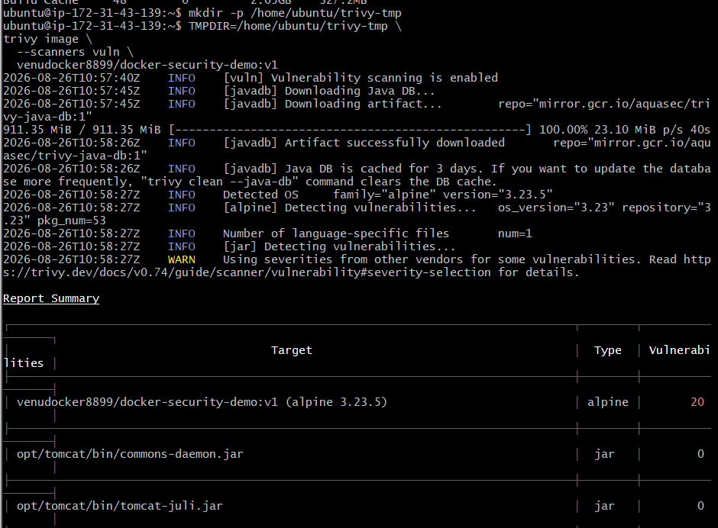
Show only HIGH and CRITICAL vulnerabilities:
TMPDIR=/home/ubuntu/trivy-tmp \
trivy image \
--scanners vuln \
--pkg-types os \
--severity HIGH,CRITICAL \
venudocker8899/docker-security-demo:v1
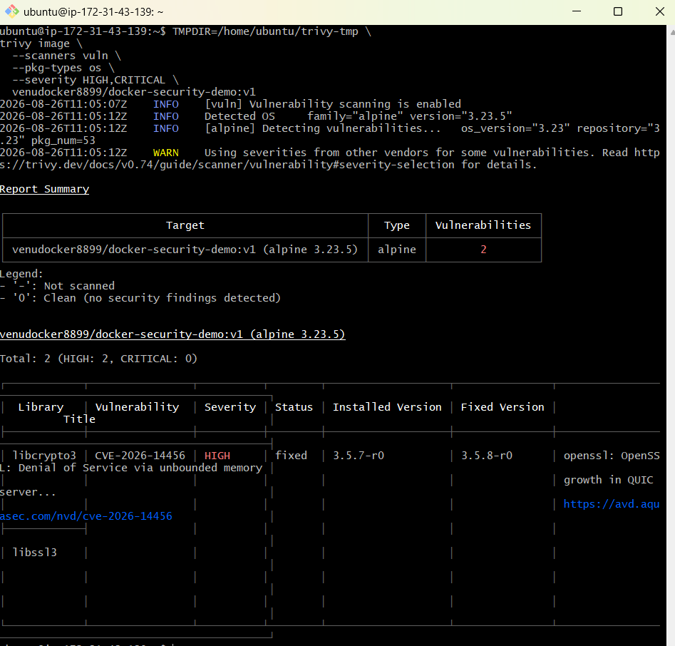
Step 5: Log in to Docker Hub
docker login -u venudocker8899
When prompted for the password, paste your Docker Hub personal access token.
Expected:
Login Succeeded
Do not enter the token directly inside the command.
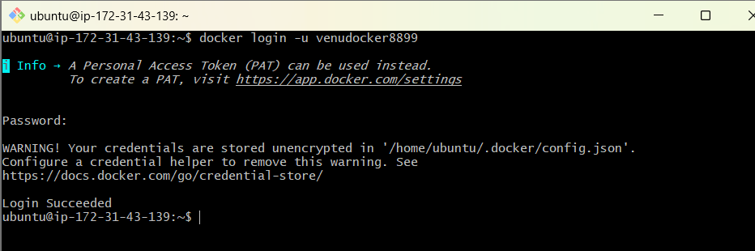
Step 6: Push the image to Docker Hub
docker push \
venudocker8899/docker-security-demo:v1
Expected ending:
v1: digest: sha256:...
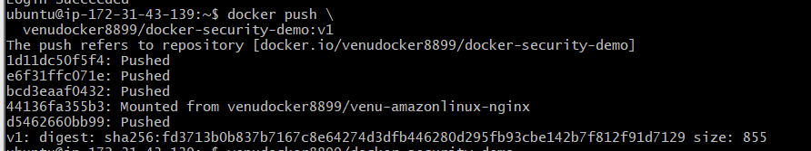
Verify the repository on Docker Hub:
docker manifest inspect \
venudocker8899/docker-security-demo:v1
The v1 tag should be visible.
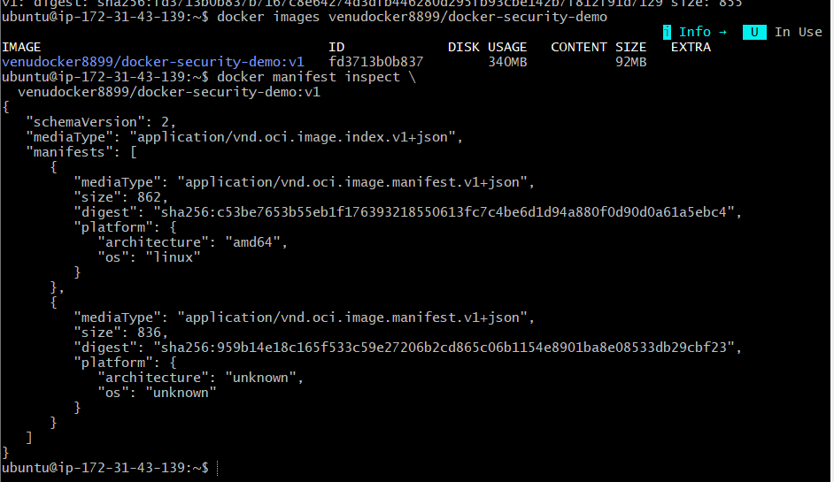
Step 7: Scan the image from Docker Hub
Force Trivy to read the image from the remote registry instead of the local Docker engine:
TMPDIR=/home/ubuntu/trivy-tmp \
trivy image \
--image-src remote \
--scanners vuln \
--pkg-types os \
venudocker8899/docker-security-demo:v1
Show only HIGH and CRITICAL vulnerabilities:
TMPDIR=/home/ubuntu/trivy-tmp \
trivy image \
--image-src remote \
--scanners vuln \
--pkg-types os \
--severity HIGH,CRITICAL \
venudocker8899/docker-security-demo:v1
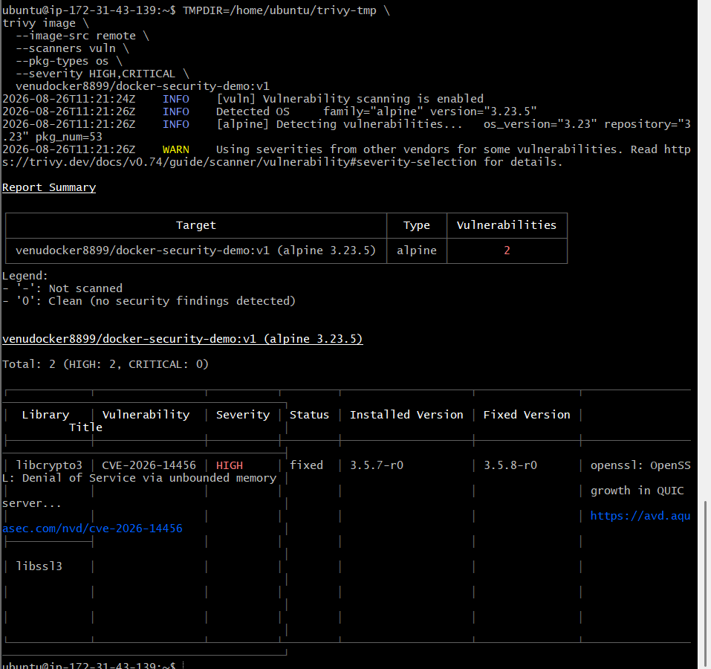
Step 8: Create an automatic push-and-scan script
Create a directory for the task:
mkdir -p ~/docker-security
cd ~/docker-security
Create the script:
nano push-and-scan.sh
Paste:
#!/bin/bash

set -e

IMAGE="venudocker8899/docker-security-demo:v1"

export TMPDIR="/home/ubuntu/trivy-tmp"

mkdir -p "$TMPDIR"

echo "Pushing $IMAGE to Docker Hub..."
docker push "$IMAGE"

echo "Scanning $IMAGE from Docker Hub..."
trivy image \
--image-src remote \
--scanners vuln \
--pkg-types os \
--severity HIGH,CRITICAL \
--exit-code 1 \
"$IMAGE"

echo "Security scan passed."
Save:
Ctrl+O → Enter → Ctrl+X
Give execution permission:
chmod +x push-and-scan.sh
Run:
./push-and-scan.sh
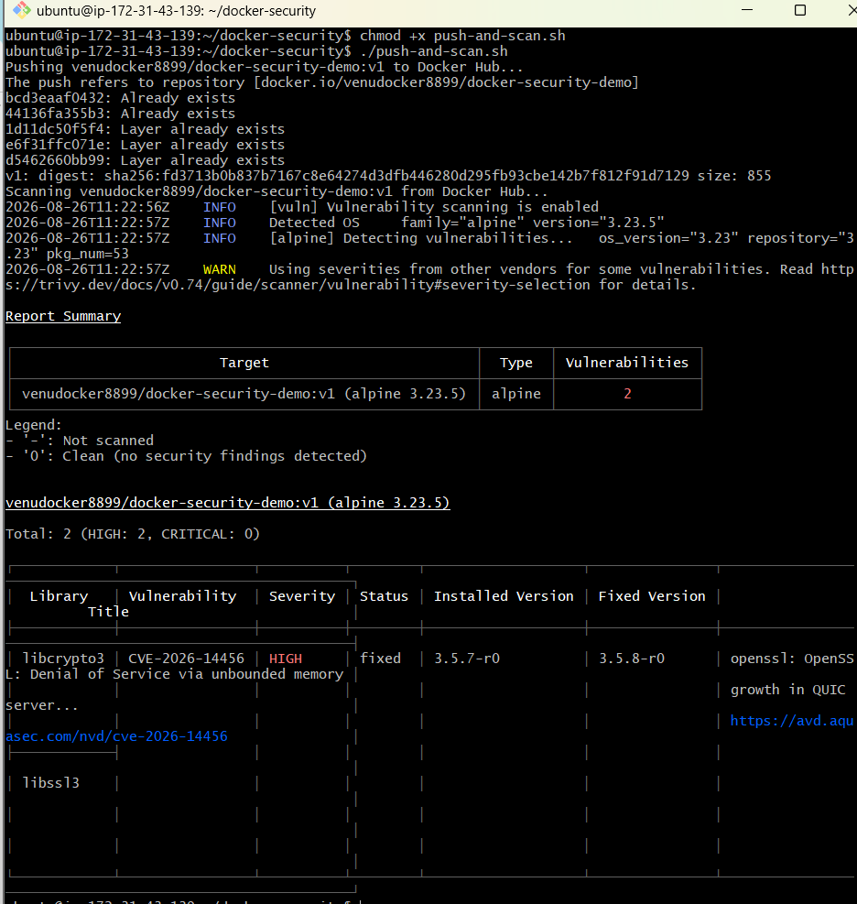
Understanding the result
If no HIGH or CRITICAL vulnerabilities are found:
Security scan passed.
If HIGH or CRITICAL vulnerabilities are found, Trivy prints the findings and returns exit code 1. Because the script uses set -e, it stops and does not print the success message.
Check the exit code immediately:
echo $?
Exit code | Meaning
0 | Scan passed
1 | HIGH or CRITICAL vulnerabilities found
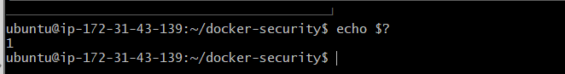
Task 6 workflow
Build image
↓
Push to Docker Hub
↓
Trivy pulls from Docker Hub
↓
Scan OS packages
↓
Pass or fail based on severity
This script can later be placed inside Jenkins or another CI/CD pipeline so every pushed image is automatically scanned.

To display the findings again:
TMPDIR=/home/ubuntu/trivy-tmp \
trivy image \
--image-src remote \
--scanners vuln \
--pkg-types os \
--severity HIGH,CRITICAL \
venudocker8899/docker-security-demo:v1
Without --exit-code 1, Trivy displays the report without failing the command.
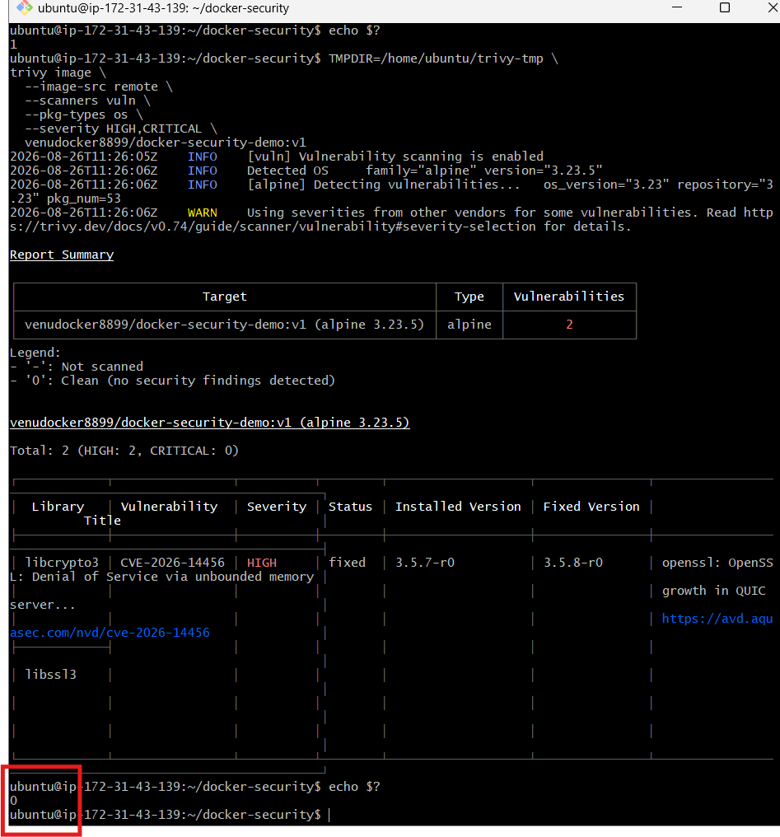
Task 7: Scan images automatically when pushed to AWS ECR
We will use your existing details:
AWS account: 800380167135
Region: ap-south-1
ECR repository: venu-amazonlinux-nginx
Use the same main EC2 Docker server:
ubuntu@ip-172-31-43-139
Step 1: Verify AWS CLI
aws --version
Expected format:
aws-cli/2.x.x
If you receive aws: command not found, install AWS CLI:
sudo apt update
sudo apt install -y curl unzip
curl "https://awscli.amazonaws.com/awscli-exe-linux-x86_64.zip" \
-o /tmp/awscliv2.zip
cd /tmp
unzip -q awscliv2.zip
sudo ./aws/install
Verify:
aws --version
Return to your home directory:
cd ~
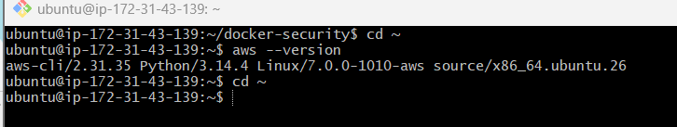
Step 2: Verify AWS authentication
aws sts get-caller-identity
A successful result should contain:
{
"UserId": "...",
"Account": "800380167135",
"Arn": "..."
}
If it returns:
Unable to locate credentials
stop there. We must attach the correct IAM role to the EC2 instance; do not run aws configure with permanent access keys yet.
Run these two commands and send me their output:
aws --version
aws sts get-caller-identity
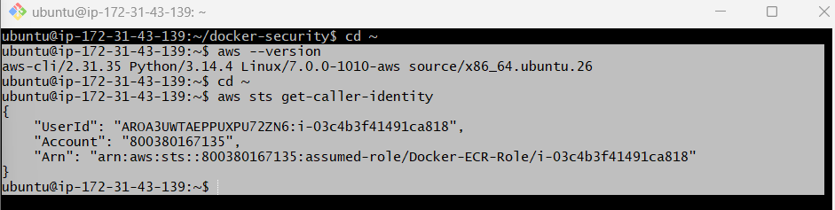
AWS CLI and IAM role authentication are working correctly:
Role: Docker-ECR-Role
Account: 800380167135
Instance: i-03c4b3f41491ca818
This IAM role avoids storing permanent AWS access keys on the server.
Step 3: Verify the ECR repository
aws ecr describe-repositories \
--repository-names venu-amazonlinux-nginx \
--region ap-south-1 \
--query 'repositories[0].[repositoryName,repositoryUri]' \
--output table
Expected repository URI:
800380167135.dkr.ecr.ap-south-1.amazonaws.com/venu-amazonlinux-nginx
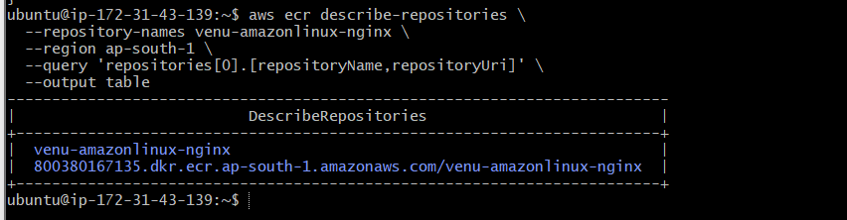
Step 4: Check the current scanning configuration
aws ecr get-registry-scanning-configuration \
--region ap-south-1
Look for:
scanType: BASIC
Step 5: Enable scan-on-push for this repository
aws ecr put-registry-scanning-configuration \
--scan-type BASIC \
--rules '[{"scanFrequency":"SCAN_ON_PUSH","repositoryFilters":[{"filter":"venu-amazonlinux-nginx","filterType":"WILDCARD"}]}]' \
--region ap-south-1
This configures:
Repository: venu-amazonlinux-nginx
Scanning type: Basic
Frequency: Scan on push
Repositories that do not match this filter remain on manual scanning.
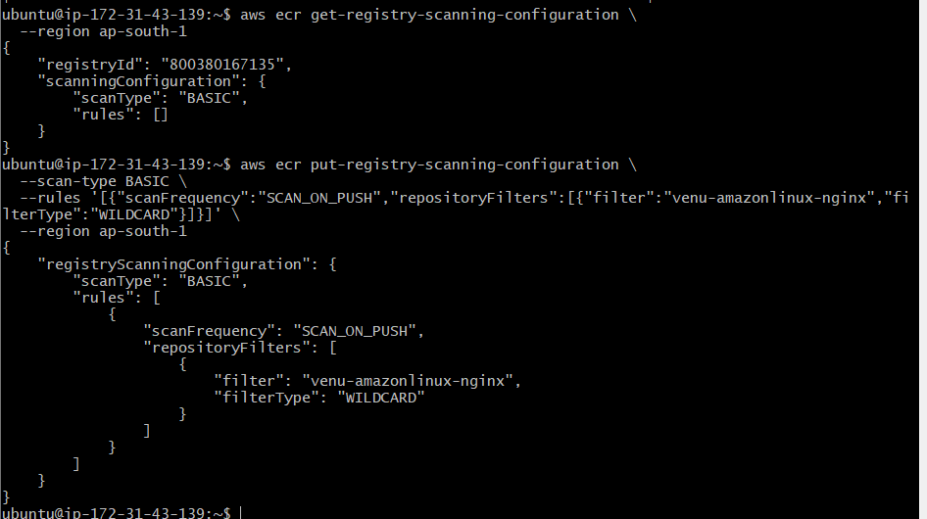
Verify:
aws ecr get-registry-scanning-configuration \
--region ap-south-1 \
--query 'scanningConfiguration' \
--output json
Expected structure:
{
"scanType": "BASIC",
"rules": [
{
"scanFrequency": "SCAN_ON_PUSH",
"repositoryFilters": [
{
"filter": "venu-amazonlinux-nginx",
"filterType": "WILDCARD"
}
]
}
]
}
If put-registry-scanning-configuration returns an AccessDeniedException, send me that output—the EC2 role will need one additional ECR permission. AWS ECR scan-on-push configuration
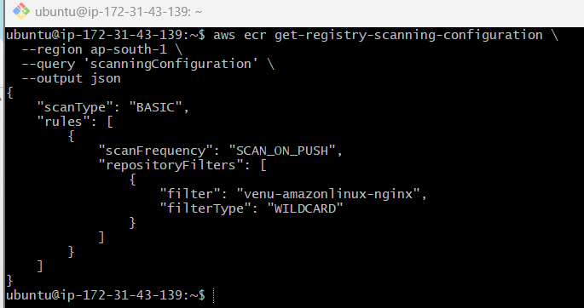
Step 6: Log in to AWS ECR
This command fixes the earlier no basic auth credentials error:
aws ecr get-login-password \
--region ap-south-1 \
| docker login \
--username AWS \
--password-stdin \
800380167135.dkr.ecr.ap-south-1.amazonaws.com
Expected:
Login Succeeded
The ECR authentication token is valid for 12 hours.
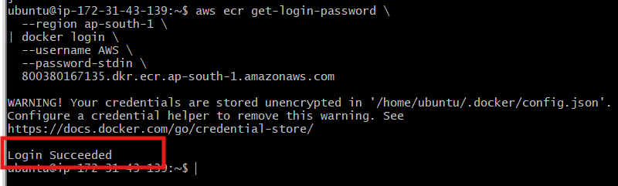
Step 7: Tag the Docker image for ECR
Use the Alpine-Tomcat image from Task 3:
docker images venu-alpine-tomcat
Tag it:
docker tag \
venu-alpine-tomcat:v1 \
800380167135.dkr.ecr.ap-south-1.amazonaws.com/venu-amazonlinux-nginx:security-scan-v1
Verify:
docker images \
800380167135.dkr.ecr.ap-south-1.amazonaws.com/venu-amazonlinux-nginx
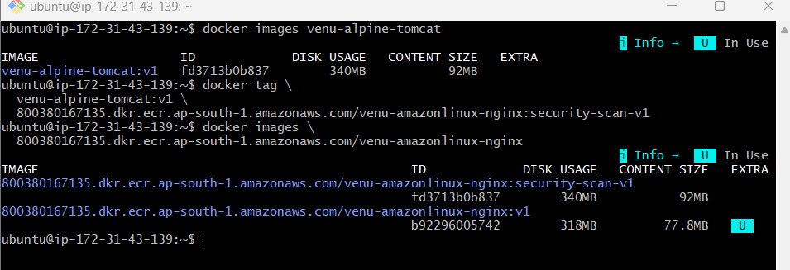
Step 8: Push the image to ECR
docker push \
800380167135.dkr.ecr.ap-south-1.amazonaws.com/venu-amazonlinux-nginx:security-scan-v1
Expected ending:
security-scan-v1: digest: sha256:...
Because scan-on-push is enabled, ECR automatically starts scanning this image.
Step 9: Wait for the scan to finish
aws ecr wait image-scan-complete \
--repository-name venu-amazonlinux-nginx \
--image-id imageTag=security-scan-v1 \
--region ap-south-1
The command may show no output when it completes successfully.
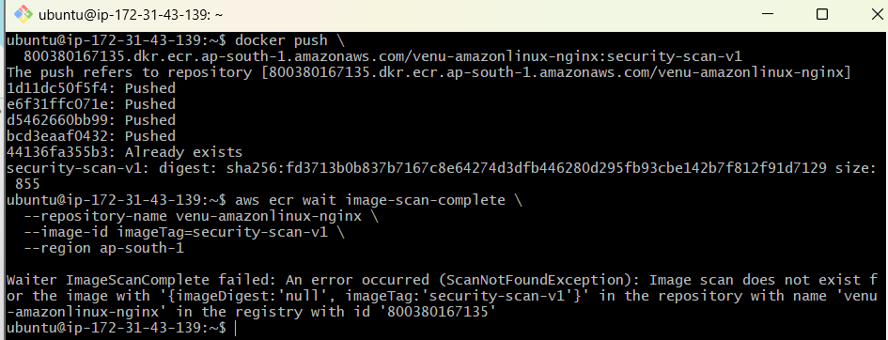
Step 10: Build a new image with unique metadata
Build from the existing Alpine-Tomcat project:
docker build \
--label security.scan.version=v2 \
-t 800380167135.dkr.ecr.ap-south-1.amazonaws.com/venu-amazonlinux-nginx:security-scan-v2 \
~/alpine-tomcat
Verify the local image:
docker images \
800380167135.dkr.ecr.ap-south-1.amazonaws.com/venu-amazonlinux-nginx
You should see:
security-scan-v1
security-scan-v2
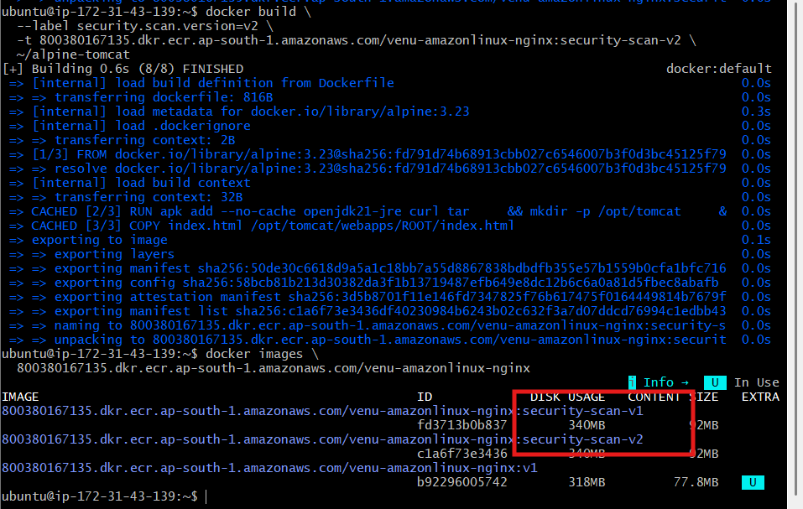
Step 11: Log in to ECR
aws ecr get-login-password \
--region ap-south-1 \
| docker login \
--username AWS \
--password-stdin \
800380167135.dkr.ecr.ap-south-1.amazonaws.com
Expected:
Login Succeeded
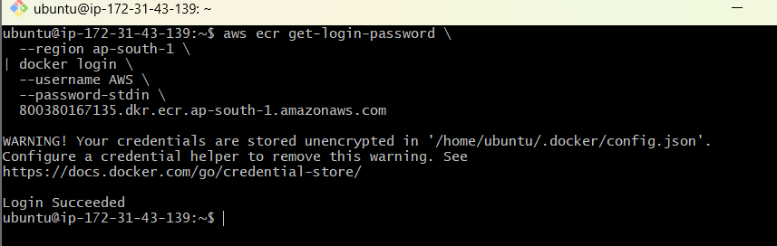
Step 12: Push the new image
docker push \
800380167135.dkr.ecr.ap-south-1.amazonaws.com/venu-amazonlinux-nginx:security-scan-v2
Expected ending:
security-scan-v2: digest: sha256:...
Step 13: Verify the image in ECR
aws ecr describe-images \
--repository-name venu-amazonlinux-nginx \
--image-ids imageTag=security-scan-v2 \
--region ap-south-1 \
--query 'imageDetails[0].{
Tags:imageTags,
Digest:imageDigest,
PushedAt:imagePushedAt
}' \
--output json
Confirm the digest differs from the earlier security-scan-v1 digest:
sha256:fd3713b0...
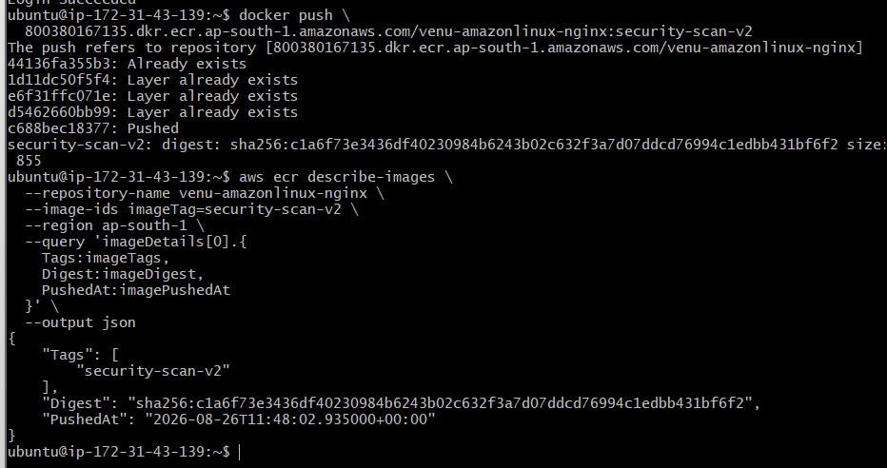
Corrected Step 14: Check the v2 image media type
aws ecr describe-images \
--repository-name venu-amazonlinux-nginx \
--image-ids imageTag=security-scan-v2 \
--region ap-south-1 \
--query 'imageDetails[0].imageManifestMediaType' \
--output text
Possible problematic result:
application/vnd.oci.image.index.v1+json
Step 15: Build a directly scannable v3 image
docker build \
--platform linux/amd64 \
--provenance=false \
--label security.scan.version=v3 \
-t 800380167135.dkr.ecr.ap-south-1.amazonaws.com/venu-amazonlinux-nginx:security-scan-v3 \
~/alpine-tomcat
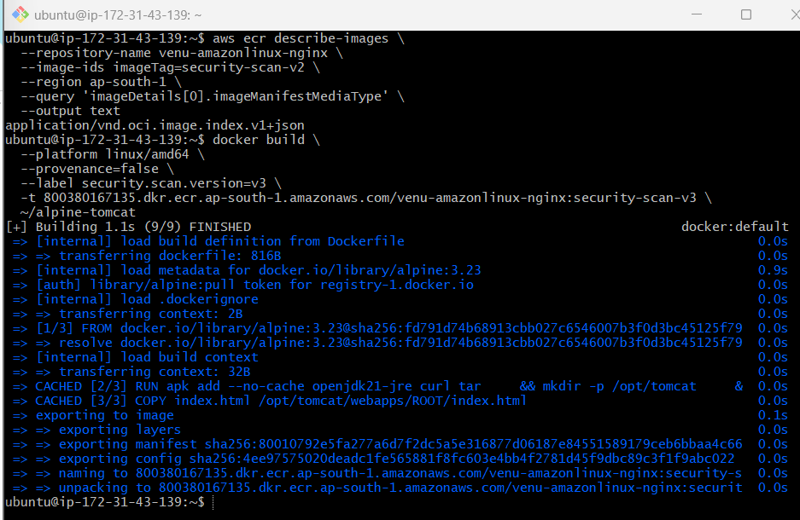
Step 16: Push v3 to ECR
docker push \
800380167135.dkr.ecr.ap-south-1.amazonaws.com/venu-amazonlinux-nginx:security-scan-v3
Step 17: Verify the v3 media type
aws ecr describe-images \
--repository-name venu-amazonlinux-nginx \
--image-ids imageTag=security-scan-v3 \
--region ap-south-1 \
--query 'imageDetails[0].imageManifestMediaType' \
--output text
Expected:
application/vnd.oci.image.manifest.v1+json
or:
application/vnd.docker.distribution.manifest.v2+json
Step 18: Wait for scan-on-push
aws ecr wait image-scan-complete \
--repository-name venu-amazonlinux-nginx \
--image-id imageTag=security-scan-v3 \
--region ap-south-1
Check:
echo $?
Expected:
0
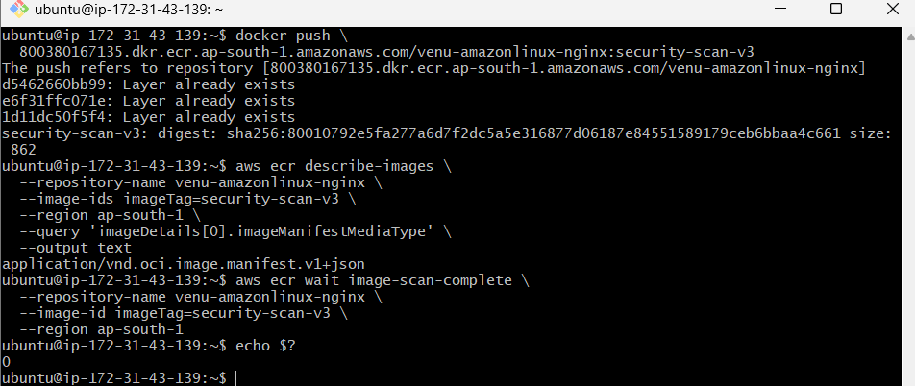
Step 19: Retrieve scan findings
aws ecr describe-image-scan-findings \
--repository-name venu-amazonlinux-nginx \
--image-id imageTag=security-scan-v3 \
--region ap-south-1 \
--query '{
Status:imageScanStatus.status,
Description:imageScanStatus.description,
Vulnerabilities:imageScanFindings.findingSeverityCounts
}' \
--output json
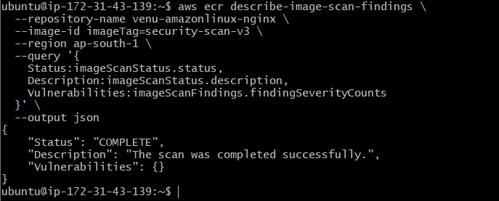
The successful workflow was:
Build single-platform image
↓
Disable provenance metadata
↓
Push security-scan-v3 to ECR
↓
ECR scan-on-push triggered
↓
Scan completed successfully
↓
No vulnerabilities found

Task 8: Jenkins pipeline to build and push a Docker image
For this task, use your Jenkins EC2 server, not the current Ubuntu Docker Practice server.
Current server: ubuntu@ip-172-31-43-139 → Docker practice
Required server: Jenkins01 / Jenkins server → Task 8
The pipeline workflow will be:
Git clone → Create Dockerfile → Build image → Docker login → Push to Docker Hub
Step 1: Connect to the Jenkins server
Connect using the key associated with your Jenkins EC2 instance:
ssh -i /path/to/jenkins-key.pem ec2-user@JENKINS_PUBLIC_IP
Your Jenkins server is Amazon Linux 2023, so the username should normally be:
ec2-user
Step 2: Verify Jenkins and Docker
On the Jenkins server:
sudo systemctl status jenkins
Check Docker:
docker --version
sudo systemctl status docker
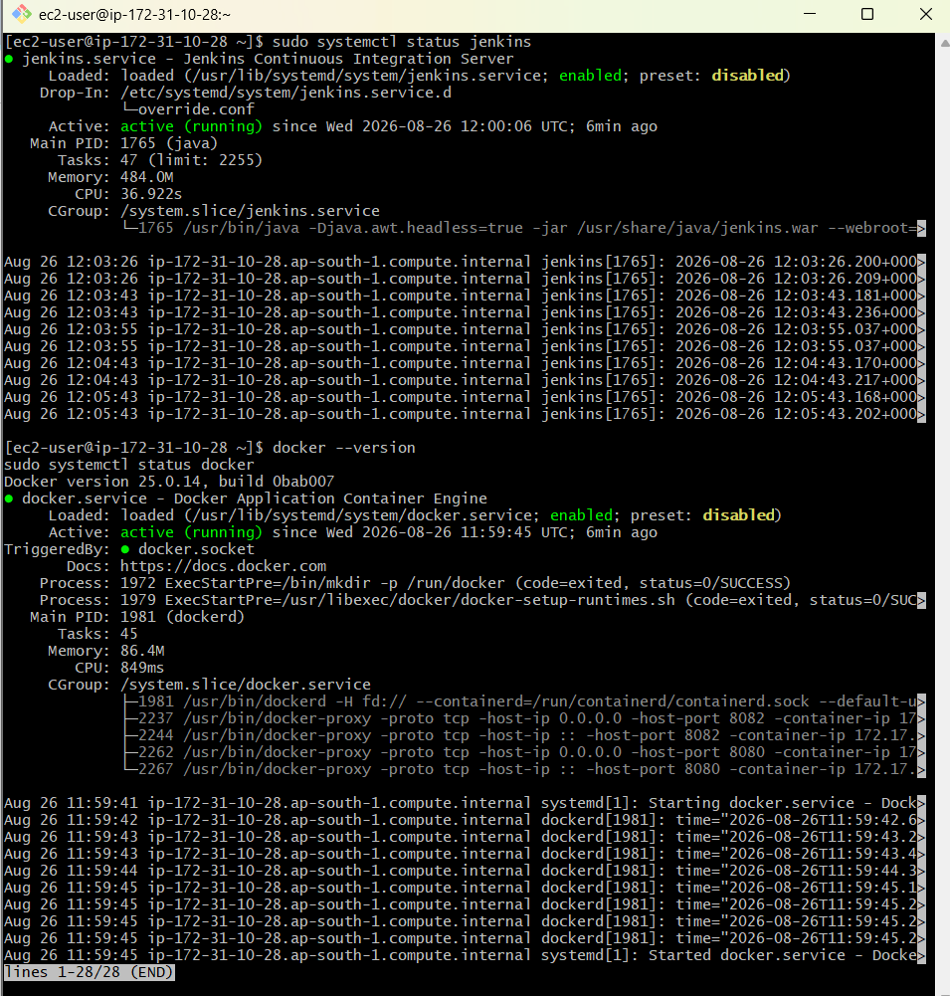
Check whether the Jenkins user can access Docker:
sudo -u jenkins docker ps
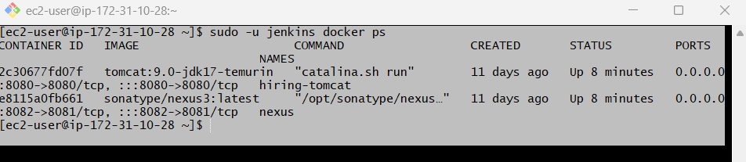
Step 3: Create a Docker Hub repository
Open Docker Hub and create:
Repository name: jenkins-docker-pipeline
Visibility: Public
The complete image name will be:
venudocker8899/jenkins-docker-pipeline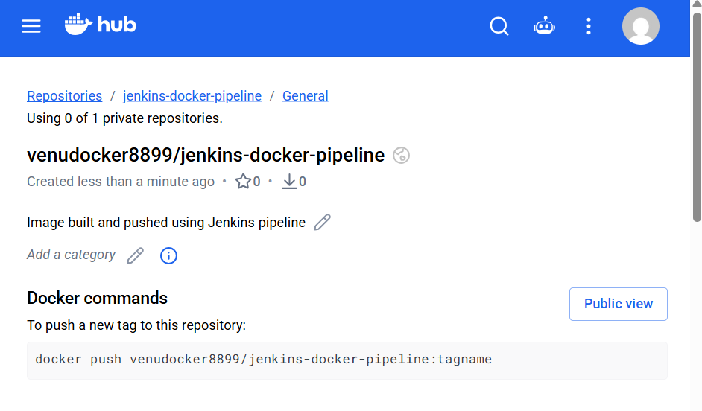 Step 4: Add Docker Hub credentials to Jenkins
Open Jenkins:
http://JENKINS_PUBLIC_IP:8081
Navigate to:
Manage Jenkins
→ Credentials
→ System
→ Global credentials (unrestricted)
→ Add Credentials
Enter:
Kind: Username with password
Scope: Global
Username: venudocker8899
Password: Docker Hub personal access token
ID: dockerhub-credentials
Description: Docker Hub Push Credentials
Click Create.
Use the Docker Hub token—not your normal password. Do not place the token directly inside the Jenkinsfile.
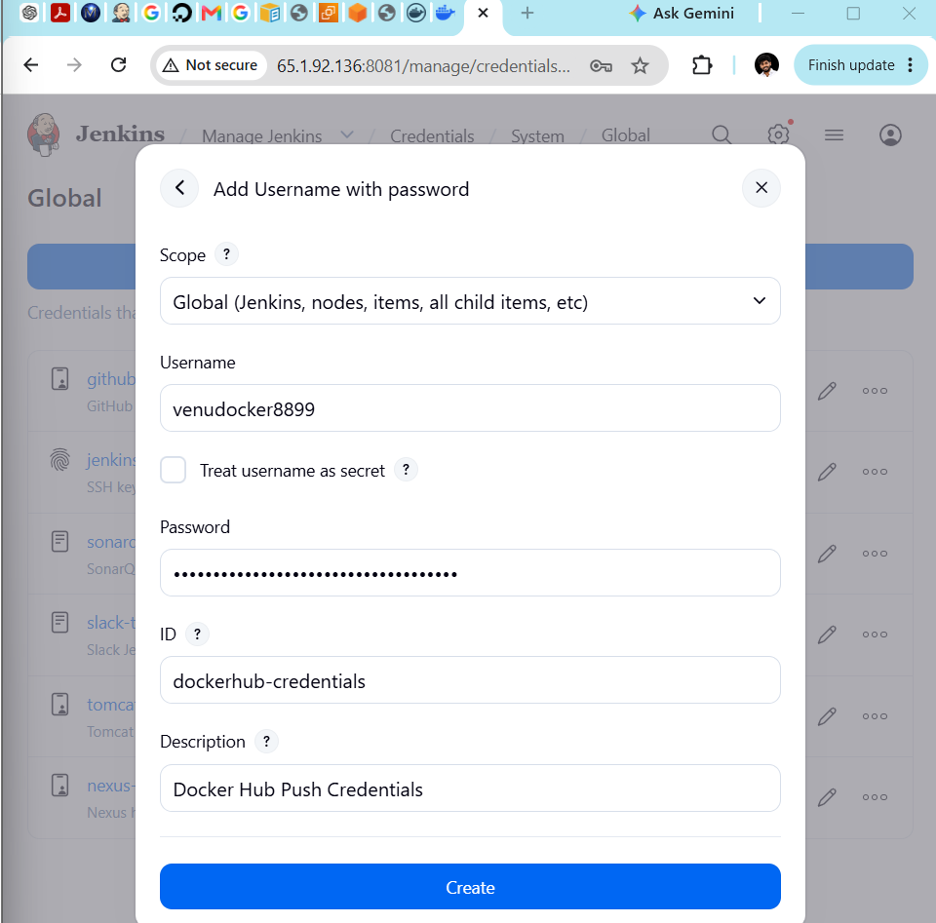
Step 5: Verify the required Jenkins plugins
Go to:
Manage Jenkins → Plugins → Installed plugins
Confirm:
Pipeline
Git
Credentials Binding
We will use normal shell-based Docker commands, so the Docker Pipeline plugin is not mandatory.
Before creating the pipeline job, confirm this command succeeds on Jenkins EC2:
sudo -u jenkins docker ps
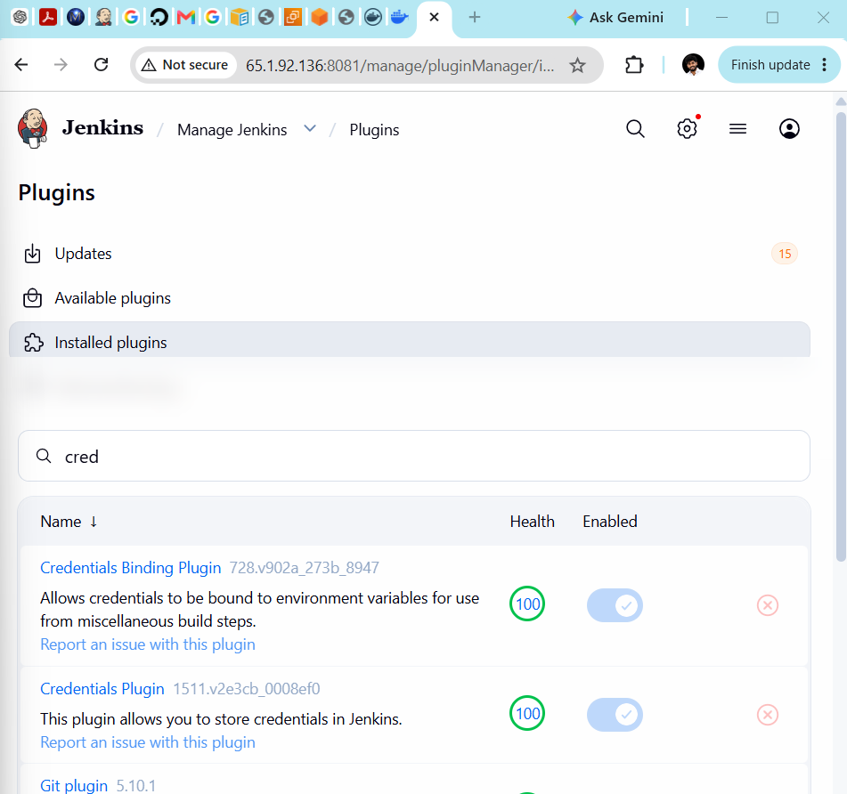

Step 6: Create the Jenkins Pipeline job
From the Jenkins dashboard:
- Click New Item.
- Enter:
08-Docker-Build-Push-Pipeline
- Select Pipeline.
- Click OK.
General configuration
Select:
Discard old builds
Enter:
Days to keep builds: 7
Max number of builds to keep: 10
Scroll down to the Pipeline section.
Select:
Definition: Pipeline script
Step 7: Add the complete pipeline script
Paste this script into the Script box:
pipeline {
agent any

environment {
IMAGE_NAME = 'venudocker8899/jenkins-docker-pipeline'
DOCKERFILE = 'Dockerfile.jenkins'
}

options {
timestamps()
disableConcurrentBuilds()
buildDiscarder(
logRotator(
daysToKeepStr: '7',
numToKeepStr: '10'
)
)
}

stages {
stage('Git Checkout') {
steps {
deleteDir()

git branch: 'master',
url: 'https://github.com/betawins/multi-stage-example.git'
}
}

stage('Create Dockerfile') {
steps {
writeFile file: "${DOCKERFILE}", text: '''
FROM maven:3.8.8-eclipse-temurin-8 AS builder

WORKDIR /app

COPY pom.xml .
COPY src ./src

RUN mvn clean package -DskipTests

FROM eclipse-temurin:8-jre-alpine

WORKDIR /app

COPY --from=builder /app/target/multi-stage-example-0.0.1-SNAPSHOT.jar app.jar

EXPOSE 8080

ENTRYPOINT ["java", "-jar", "app.jar"]
'''
sh '''
echo "Dockerfile created:"
cat ${DOCKERFILE}
'''
}
}

stage('Build Docker Image') {
steps {
sh '''
docker build \
-f ${DOCKERFILE} \
-t ${IMAGE_NAME}:${BUILD_NUMBER} \
-t ${IMAGE_NAME}:latest \
.
'''
}
}

stage('Verify Docker Image') {
steps {
sh '''
docker images ${IMAGE_NAME}
docker inspect ${IMAGE_NAME}:${BUILD_NUMBER} \
--format="Image ID: {{.Id}}"
'''
}
}

stage('Docker Hub Login') {
steps {
withCredentials([
usernamePassword(
credentialsId: 'dockerhub-credentials',
usernameVariable: 'DOCKER_USER',
passwordVariable: 'DOCKER_TOKEN'
)
]) {
sh '''
echo "$DOCKER_TOKEN" | \
docker login \
--username "$DOCKER_USER" \
--password-stdin
'''
}
}
}

stage('Push Version Tag') {
steps {
sh '''
docker push ${IMAGE_NAME}:${BUILD_NUMBER}
'''
}
}

stage('Push Latest Tag') {
steps {
sh '''
docker push ${IMAGE_NAME}:latest
'''
}
}
}

post {
success {
echo "SUCCESS: ${IMAGE_NAME}:${BUILD_NUMBER} was pushed to Docker Hub."
echo "SUCCESS: ${IMAGE_NAME}:latest was pushed to Docker Hub."
}

failure {
echo 'FAILED: Check the failed stage and console output.'
}

always {
sh '''
docker logout || true
'''
}
}
}
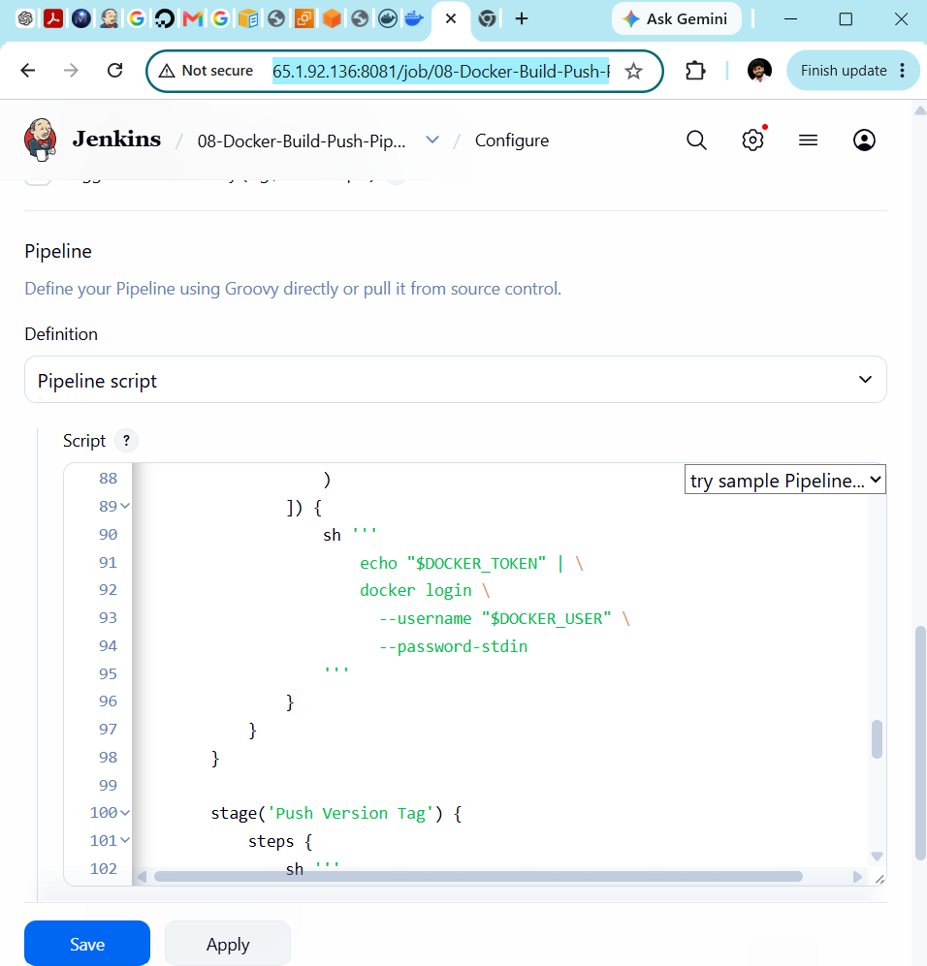
Step 8: Check important pipeline values
Before saving, confirm these values:
IMAGE_NAME = 'venudocker8899/jenkins-docker-pipeline'
credentialsId: 'dockerhub-credentials'
The credential ID must exactly match the ID created in Jenkins:
dockerhub-credentials
The source repository uses the master branch:
git branch: 'master'
Step 9: Save the pipeline
Click:
Save
You should be redirected to the job page:
08-Docker-Build-Push-Pipeline
Step 10: Run the pipeline
Click:
Build Now
A build should appear under Build History, such as:
#1
Click the build number and open:
Console Output
Step 11: Expected pipeline stages
The following stages should run:
1. Git Checkout
2. Create Dockerfile
3. Build Docker Image
4. Verify Docker Image
5. Docker Hub Login
6. Push Version Tag
7. Push Latest Tag
Expected final result:
Finished: SUCCESS
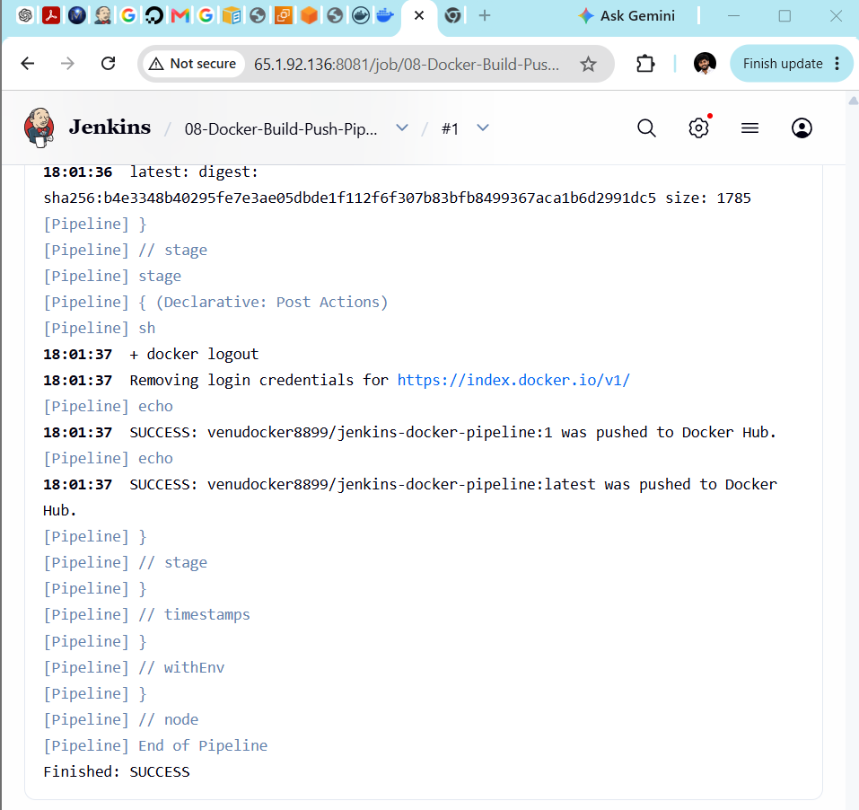
Step 12: Verify images on the Jenkins server
After the pipeline succeeds, connect to the Jenkins EC2 server and run:
docker images venudocker8899/jenkins-docker-pipeline
For Jenkins build number 1, expected:
REPOSITORY TAG
venudocker8899/jenkins-docker-pipeline 1
venudocker8899/jenkins-docker-pipeline latest
Both tags reference the same image ID.
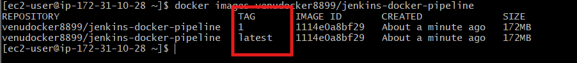
Step 13: Verify images in Docker Hub
Open:
Docker Hub tags
You should see:
1
latest
If you run the pipeline again, the next result will be:
2
latest
The numbered tag preserves each Jenkins build, while latest points to the most recent build.
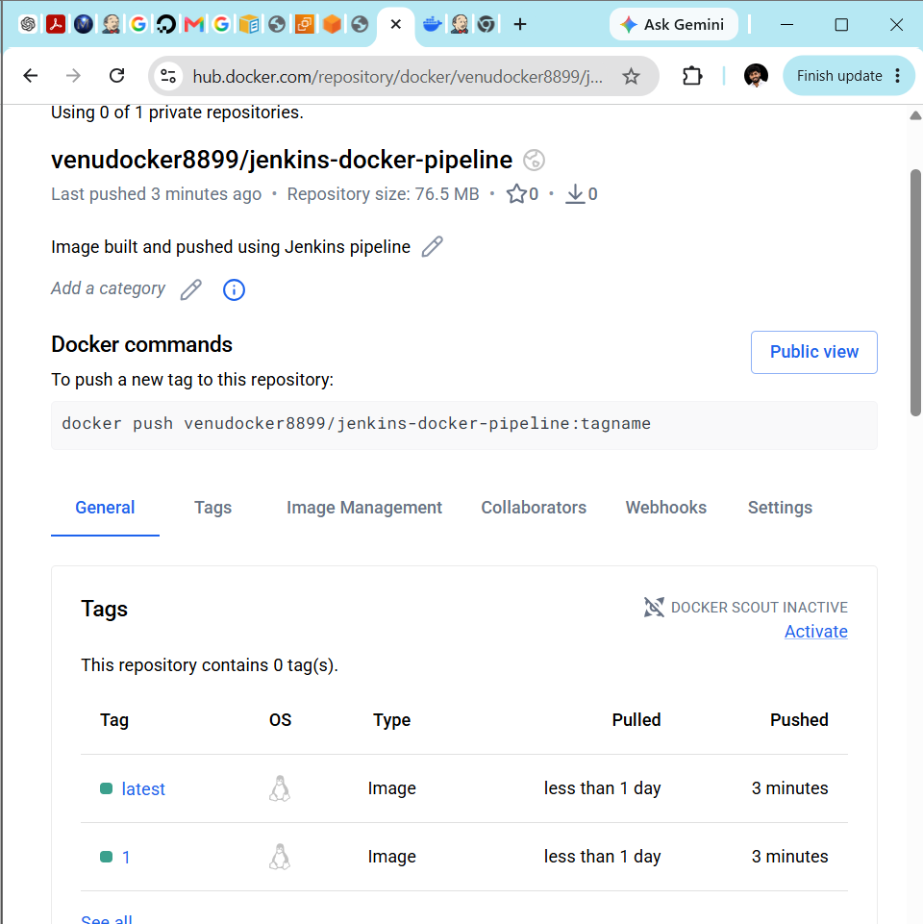
Step 14: Optional pull verification
On the Jenkins server or Docker Practice server:
docker pull \
venudocker8899/jenkins-docker-pipeline:latest
Verify:
docker images \
venudocker8899/jenkins-docker-pipeline
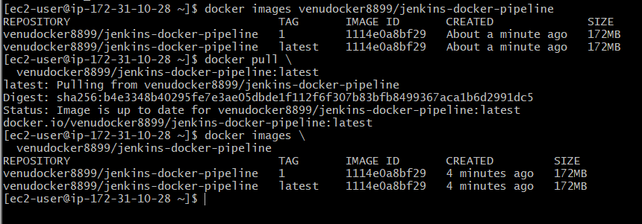
Completed workflow
GitHub source code
↓
Jenkins checkout
↓
Jenkins creates creates Dockerfile
↓
Docker builds image
↓
Jenkins uses secured Docker Hub token
↓
Push build-number tag
↓
Push latest tag

